Student Outcomes –Gen Ed Assessment
Business Department: Economics 102

The following is an example of the question that will be included in the final exam. The concept of marginal cost – marginal benefit analysis is introduced to students during the first week of class and examples are applied to a variety of situations throughout the semester. The Economics of Health Care is the last subject covered in the class and one of the following questions will be included on the final exam:

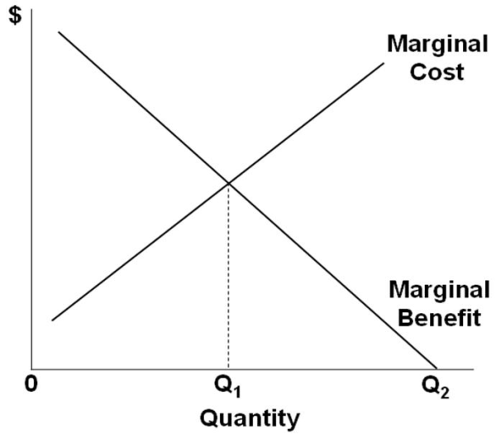
Refer to the diagram. Economists would argue that health care should be provided to patients in:
A. | some amount less than Q₁.

B. | amount Q₁.

C. | some amount between Q₁ and Q₂.

D. | amount Q₂.

Refer to the diagram. Physicians likely would argue that health care should be provided to patients in:
A. | some amount less than Q₁.

B. | amount Q₁.

C. | some amount between Q₁ and Q₂.

D. | amount Q₂.

