#2. Executive Summary: Undergraduate Program Assessment: Student Outcomes
To be completed by Departments and submitted by the Department Chair to the Assessment Blackboard Site

Department: Business Date: 7/15/16
Members involved with analysis of artifacts:
T. Heidorn, A. Langewisch, S. Leinen
See #1 Undergraduate Program Assessment Plan Student Outcomes for:
a) Student Outcome; b) Background; c) Question(s); d) Methodology
Analysis of artifacts:
- PERFORMANCE CRITERIA* - How was data analyzed? (attach rubrics/scoring tools if used).
For BUS 261, Marketing, 10 artifacts were each scored by two of the three department members present, using the rubric provided.
Summary of RESULTS*:
- Restate the assessment question(s) (from the Assessment plan):
Are students demonstrating an understanding of key concepts from business and able to integrate relevant sources? Are they writing well?
- Summarize the assessment results. A narrative summary is required. Charts, tables or graphs are encouraged but optional.
BUS 261: See the chart below. In terms of organization and length, application, comparison and support through research, and use of sources, students followed instructions well. The weakest trait observed was writing care, which is a perennial issue with younger college students.
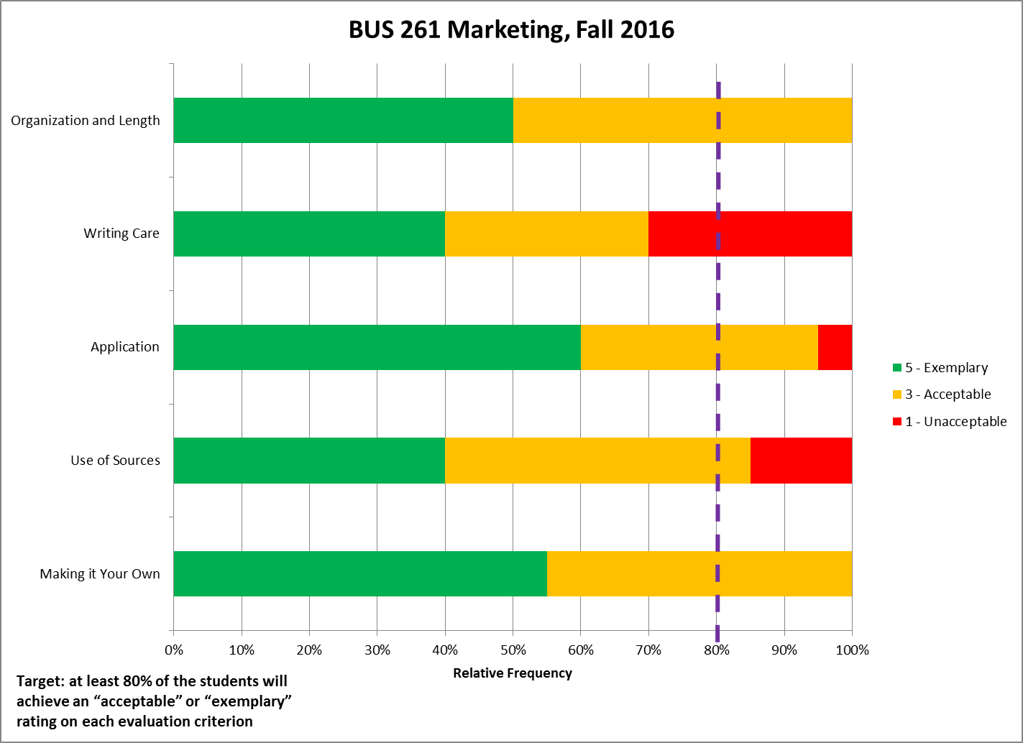
BUS 443: See the chart below. For all six measured traits, student work as a whole met department goals for acceptable or exemplary work. Students articulated well each organization's background and competitive landscape. They justified using fundamental business and organizational behavior principles why an organization should be considered an excellent company. They connected their assessments to Christian principles that would help an organization be recognized like a "beacon on a hill." They incorporated analyses of ethical issues that the organizations faced. Lastly, they wrote well--as upper-level students might be expected to do.
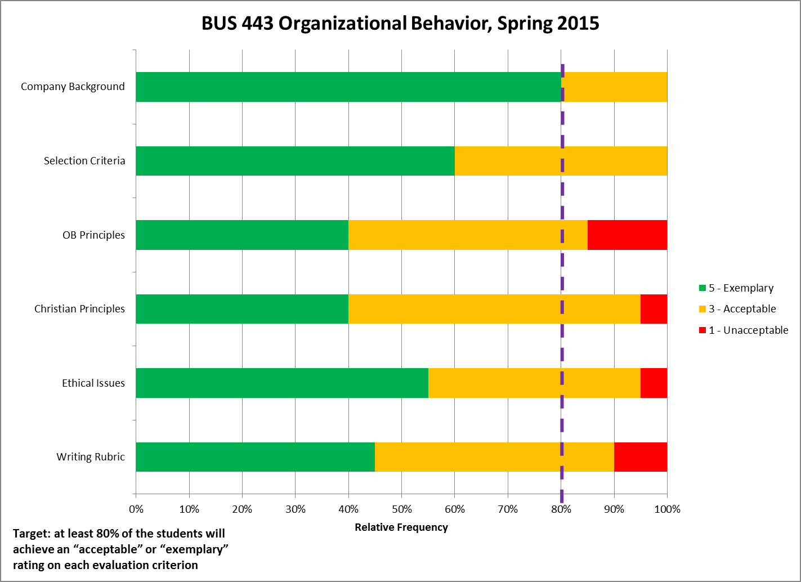

3). INTERPRETATION* - Discuss how the results answer the assessment question(s).
For BUS 261, yes, we can tell from our collective impressions that fundamental marketing concepts were frequently and correctly used. Students are indeed learning about key marketing/business topics. The process of scoring and aggregating scores reinforced for us that we had a valuable assignment, that we are measuring and evaluating the right traits associated with the assessment questions, and that the students generally submitted very good work. Most students connected their analyses with referenced text sources and outside sources. While student writing can always be improved, the papers scored here were just shy of meeting the 80% acceptable or exemplary target, so we would judge that they are writing reasonably well.
For BUS 443, yes, the high scores support the conclusion that the students do understand key concepts from business, are able to integrate relevant sources, and they are writing well. They are integrating knowledge and application from Human Resources Management, Organizational Behavior, Ethics, and their Christian training. As with BUS 261, the process confirmed for us that we had a very good assignment, a very good method of measuring, and very good results.
Sharing of Results:
When were results shared? Date:
7/15/16
How were the results shared? (i.e. met as a department)
We met as a subset of the department, and refined the document via email.
Who were results shared with? (List names):
C. Beck, A. Langewisch, S. Leinen, T. Heidorn
Discussion of Results –ACTION*- Summarize your conclusions including:
- How will what the department learned from the assessment POTENTIALLY impact the teaching/learning process in your department starting the next academic year?
BUS 261 Students were allowed to choose their own companies for their Marketing Plan Project. This course could possibly be more successful in student writing if students were given a list of businesses, with plentiful resources, to choose from. This course allowed for the students to submit several edited drafts as their paper grew into the final submission.
- How will the program POTENTIALLY use the results to improve student achievement of the learning outcome in the next academic year?
Offering peer-editing could also produce better results as dialogue could open up suggestions between peers for research and writing advancement.
If action is taken – it is recommended that the same plan be used for a second assessment cycle.
FEEDBACK* - Reassess outcomes if ACTION* has been taken.
A new professor will be teaching the course beginning in Fall 2016. We will share the results and insights gained so far.
What assessment questions related to the learning outcome would the program like to investigate in the future?
This should be a good question to track distributions of rubric scores over time, and to monitor the efficacy of continuing improvement efforts.
Submitted by:
Andy Langewisch
Reviewed by the Assessment Committee (date): 6/29/16

Department Chair notified/additional action needed: 6/29/16 Date posted to Assessment site: 6/29/16

BUS 261 Company Case Study Rubric

Trait | Unacceptable (1) | Acceptable (3) | Exemplary (5) | Points Awarded
Organization and Completion:  - The case study was organized well with headings for different sections and flowed well.  - Submitted case study is 3 pages in length | Poor organization and much less than the expected length / content | Organized, but less than the expected length / content | Well organized and complete
Application:  - It was clear that you read the material. When discussing concepts from the text, you cited the page number of the text where you found the concept  - Concepts from the text were correctly applied to the subject of the case study | Poor application throughout; appeared to not understand the concepts nor have the ability to apply them to the facts throughout; no citations of the page number of the textbook | Applied the concepts and cited the text page numbers inconsistently | Great application of the concepts throughout including citation of page numbers from the text
Writing Care:  - There were no grammar or spelling errors | More than two spelling or grammar errors | Less than two spelling or grammar errors | No spelling or grammar errors
Use of Sources:  - Aside from the textbook, you used a minimum of two additional outside sources that were credible. Examples of credible outside sources would be: a) the company’s website; b) www.sec.gov: the website for the Securities Exchange Commission; c) business websites such as cnnmoney.com, forbes.com, yahoofinance.com, or Bloomberg.com; or d) a credible business journal, academic journal, or magazine such as Forbes, St. Louis Business Journal  - There should be in-text citations for these sources within your paper along with a bibliography section at the end | No outside sources used or sources listed in the bibliography section, but no in-text citations of sources are present within the body of the paper | Less than two outside sources used,  textbook not used,  or  inconsistent citing throughout the paper | Two outside credible sources used along with the textbook and sources cited consistently throughout the paper
Trait | Unacceptable (1) | Acceptable (3) | Exemplary (5) | Points Awarded
Making it Your Own  - You should not under any circumstances try to copy/paste language from a website or document and try to claim it as your own. If I find that you’ve done so from another student or from another website/document and have not cited the source, that is considered plagiarism and you will receive a 0 for the assignment.  - If you find language that is earth-shattering that you think cannot be put another way, you must use quotation marks and cite the source where you found it. This is fine for a 1-2 line sentence. Anything more than that, I will want you to use that information and twist it/apply it in your own way. Essentially, copying/pasting a paragraph to help you reach the three-page minimum will not work. | Source material was used directly and not quoted |  | Source material was put into own words or properly quoted
TOTAL POINTS

