Introduction

Student Teacher Heather Niedfeldt
Cooperating Teacher Mrs. Ashlee Rickert
School Utica Centennial Public High School

Context of Teaching
For this project, I will be leading 10th grade English students through the characterization unit (Unit II) in their literature textbooks. I have three separate class periods involving sophomores; therefore, I will receive sufficient time and opportunities to practice, process, reflect, and modify when needed.
Many of the students are proficient in their abilities as learners; they tend to speak up if they have questions, contribute ideas to discussion, and have good attitudes when assignments are given. They follow the classroom rules and show respect to others. However, there are a few specific students who will need special attention. In fifth period, Layne struggles with ADHD and likes to discuss things off-topic. He does well when guided in individual work time. Shaughnessy is another student in fifth period that will need help in self-motivation because she tends to have trouble starting projects. In sixth period, Brianna is assisted by a paraeducator because she struggles with reading and critically thinking on her own. I predict that she will need help with brainstorming ideas in assignments. In seventh period, the students are a little chatty, so they will need more attention when keeping them on track.
This last school year, the English department at Utica received new textbooks for their classes. Because of this, they are focusing on using the textbook as much as they can in teaching their students. I plan to incorporate the short stories and poetry that are included in the text, but I will also incorporate my own activities and reading materials related to the texts to enhance diverse learning techniques as well as making it my own.

Understanding by Design: Stage 1 – Identify Desired Results

Established Goals:
LA 12.1.6.l (Nebraska Language Arts Standards)

“Comprehension: Students will extract and construct meaning using prior knowledge, applying text information, and monitoring comprehension while reading grade level text.”

More specifically:
LA 12.1.6.a “Evaluate the meaning, reliability, and validity of the text considering author’s purpose, perspective, and information from additional sources.”
LA 12.1.6.b “Analyze and evaluate narrative text (in this unit, specifically characterization).”
LA 12.1.6.g “Analyze, evaluate, and make inferences based on the characteristics of the narrative and informational genres and provide evidence from the text to support understanding.”

(http://www.education.ne.gov/AcademicStandards/index.html)

What understandings are desired?
Students will understand that…

Overarching:
-In order to understand characters, one must be able to analyze characterization (traits of a character) in literature.
-Selections of literature develop through the movement of the characters.
-Literature can teach us important insights into human nature.

Topical:
-Character development allows readers to see the more significant characters in selections.
-The more we infer or conclude in a story, the more we are able to make educated guesses about character traits based off of our own human experiences.

What essential questions will be considered?
Overarching:
-Why study characterization?
-Why study characterization in different forms of literature (fiction, nonfiction, poetry)?
-Why is making inferences through reading important?
-How does a character’s motivation influence the story’s plot?

Topical:
-What types of details about characters should be considered in a story when making conclusions about characterization?
-What are round and flat characters?
-What are static and dynamic characters?
-In each reading selection, what is the main character’s motivation(s)?
-In making inferences, what types of circumstances from real life can we personally connect to the literature?

What key knowledge and skills will students acquire as a result of this unit?
Students will know. . .
-what character traits are involved in character development.
-the importance of knowing a character’s motivation.
-the difference between round and flat characters.
-the difference between static and dynamic characters.
-the relationship between plot and characters

Students will be able to. . .
-relate or reiterate the importance and value of reading literature to enhance one’s knowledge in constructing meaning and monitoring comprehension.
-explain how characters are developed.
-make inferences and use them to better understand the characters.
-connect (relate) to situations that characters may face.
-identify the author’s perspective in a nonfiction or poetic selection.
-construct a feasible demonstration of what shapes a character through a character study report.

Pre-Assessment

Background Knowledge Probe
Name:_________________________________________
Period:__________
Before we dive into Unit II, how much do we know? Let’s find out!
- What is characterization?

- What is the difference between direct and indirect characterization?

- Give three characteristics of a round character.

- Give three characteristics of a flat character.

- A ______________________ character changes in a story (evolves and learns).

- A ______________________ character remains the same in a story (unchanged).

- What do you think making inferences means?

- How can a reader find the character’s motivation in a story? What things would you look at?

- How can a reader determine the author’s perspective in a story? What clues would you look at?
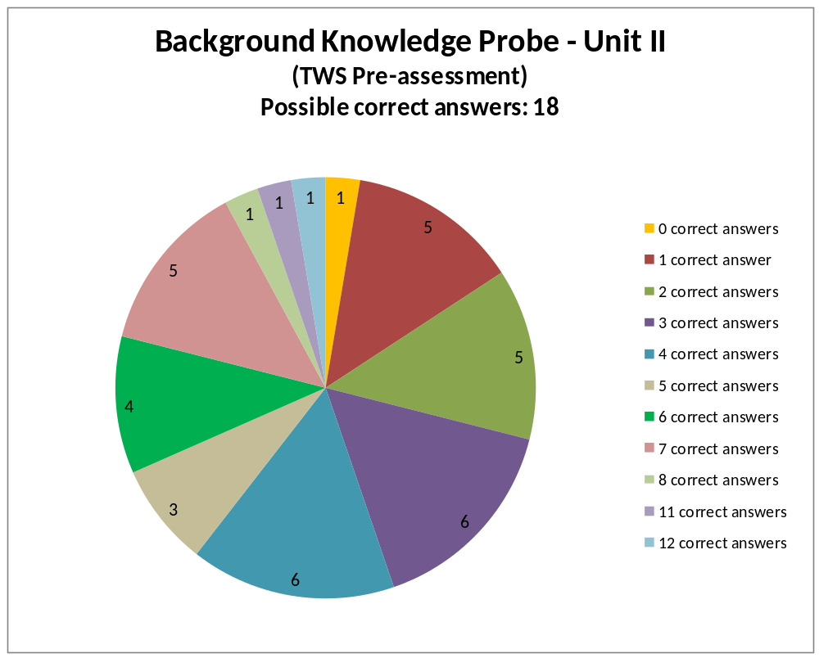
Data received after conducting the pre-assessment:
The pie chart above depicts the results of the pre-assessment that the students took. The background knowledge probe worksheet was out of a possible eighteen points. The numbers in the sections of the pie chart highlight the number of students corresponding with the score (note the legend) they received. The highest score received was a 12/18, making the highest score percentage a 67%.
If we calculate the largest areas of the chart, most of the students scored below 39% (7/18). From these results, we can gather that a greater amount of the sophomore class (89%) received a score below a 39% on their pre-assessment, while 11% received a score above a 39%.
From the information that I received, I was able to conclude that over one third of my students understood the characterization unit’s vocabulary terms that were included on the background knowledge probe (due to their work with the L to J Consulting program that Utica Centennial has implemented school-wide). While they understood them, however, they were unable to connect and apply them to the questions pertaining to the concepts of the chapter that we will be studying. They could define them; they could not explain differences, list characteristics, and determine clues as to how to find those concepts. Some students were able to make assumptions about what the questions were asking, which showed that they are able to use past knowledge to infer and break down what the questions asked of them.
It was difficult to see students (Caleb, Layne, Cory, Roger) hand in the pre-assessment with many of the questions left unanswered. Either they truly didn’t know the answers or they failed to attempt to try to answer them. It was interesting to see how some of the students (Keelan and Tanner) knew more than I predicted; it was also interesting to see that some of my more advanced students (Hunter, Cacey, Emma) scored average on the pre-assessment. This is encouraging to me as a teacher because I am able to predict a future growth in their learning.
Because students were able to define many of the definitions involved with the chapter after basic review from their L to J, I spent less time explaining the vocabulary; however, I still spent a good amount of time explaining the concepts and methods associated with those terms so that they were able to understand the full capacity of comprehensive applicable techniques involving the terms.

Understanding by Design: Stage 2 – Determine Acceptable Evidence

What evidence will show that students understand?
Performance Tasks* (summary in GRASPS form):

Facebook Page: Character Presentation
Goal:
- I want students to be able to apply the information they learned from Unit II regarding direct and indirect characterization methods, using a variety of characteristic traits they have analyzed and recorded about a specific character and presenting that information in a facebook profile page template.

Role:
- Students will choose a character from Shoofly Pie, The Possibility of Evil, A Celebration of Grandfathers, or a main character from their 3rd quarter chosen classic novel.
- Students will be able to present their understanding of their individually chosen character through their portrayal (profile) of characteristics.

Audience:
- The audience of the assignment will be the students in class and the teacher.

Situation:
- Students will be assigned the task halfway through the unit in order to give ample amount of time to choose/research a character. They will be given a half-period of class time to work on the product; the rest of the task will be expected to be finished outside of class.
- While researching the character, students will note different character traits that are described by the author through direct and indirect characterization. Such elements to analyze about the chosen character are physical traits, personal interests, thoughts, emotions, opinions, and relationships with other characters in the story.
- This situation will also benefit students by allowing them to look at and connect character statuses, behaviors, and situations with their own experiences.

Performance:
- On the final day of the unit, each student will hand in their Facebook Page: Character Presentation final assignment. The profile pages will meet the criteria included on the rubric.
- Students may be asked to share their product with another classmate in order to reflect on their individual work.

Standards:
- Students will be evaluated on: timeliness of finished work, met criteria on rubric (included below), a reflection of creativity, and appropriate evaluation of individual students’ abilities.

Performance Task Instructions and Rubric following:

Facebook: Character Presentation
How’s it going? What’s on your mind? How are you feeling? What’s going on?

Create a Facebook page for your character.

- For this assignment, choose one of the characters from Shoofly Pie, The Possibility of Evil, A Celebration of Grandfathers, OR a main character from your chosen classic novel for this semester. Your facebook page will give a profile of this character.
- Using the given worksheet template, you will include information that reflects various aspects of your character, presenting his/her characteristic traits through direct and indirect characterization methods.
- The information will be presented as if the character is sharing the facts and posts.
- Include the following information through your facebook page:
  - “Character Name” – Make sure you say who your character is! (2 pts.)
  - “Photo” – A photo that depicts your character can either be hand-drawn or feel free to paste a picture from a magazine or other source. (2 pts.)
  - “About Me” section – Share at least three facts in this box. It can be about family, occupation, fun facts they want to share, etc. (6 pts.)
  - “Liked Pages” section – List three interests you think they’d have (movies, music, favorite animal, hobbies, etc.). (3 pts.)
  - “Hometown” section – Record the story title and author of the character. (2 pts.)
  - “Status Updates” – Include three status updates from your character. This can help show the character’s speech, thoughts, emotions, opinions, etc. about what is going on in the story. (9 pts.)
  - “Wall Post” – Include one wall post from another character in the story which should either comment or highlight a behavior of your character. (3 pts.)
  - “Event Attended” – Share one event your character did or would attend in the story. Describe the event. What was it for? (3 pts.)
- Possible Points: 30 pts.
- Feel free to get creative; make sure it truly reflects your character!

Facebook: Character Presentation Rubric

Name_______________________________

Character Name  - Character name is clearly stated at the top of the facebook page. | ____/ 2 pts.
Photo  - In the box given, some type of image is included to help display their character visually. | ____/ 2 pts.
“About Me” section  - Three distinct facts are shared about the character.  (This can pertain to family, occupation, fun facts, etc. but should be in an attempt to enhance character portrayal.)  - Each fact is worth two points. | ____/ 6 pts.
“Liked Pages” section  - Three interests of the character are presented.  (Movies, music, favorite things, hobbies, etc.)  Students should feel free to be creative in this section. They can pull from the story or present how they see the character.  - Each interest listed is worth one point. | ____/ 3 pts.
Hometown Information  - Story or novel title included.  - Author name included. | ____/ 2 pts.
Status Updates  - Three status updates included from the character.  (Helps show speech, thoughts, emotions, opinions, etc.)  References should pertain to the story that the character is involved in.  - Each status update is worth three points. | ____/ 9 pts.
Wall Post  - One wall post from another character in their story is included.  (Comments or highlights behavior of character.) | ____/ 3 pts.
Event Attended  - One event is included.  (Brief description of what the event was.) | ____/ 3 pts.
Total Score | ___/ 30 pts.

General Comments:

Other Evidence (quizzes, tests, prompts, observations, dialogues, work samples):
Furthering knowledge/practice through…

-dialogues, in-class discussions
-comprehension checks (oral quizzes, Jeopardy! Game)
-graphic organizers (guided notes on introductory information, character traits for Shoofly Pie, etc.)
-worksheets (menu activity for Shoofly Pie, inferences worksheet for The Possibility of Evil)
-writing prompts/activities (notecard poems for A Celebration of Grandfathers)
-final comprehensive assessment (final test for Unit II – questions covering The Secret Life of Walter Mitty)

*Note*: These selections of evidence will be included within the lesson plans. Worksheets, activities, and the comprehensive assessment documents will also be attached throughout the lessons.

Student Self-Assessment and Reflection:
Students will self-assess the following questions pertaining to their individual progress in Unit II:

-Do you feel that you have gained more knowledge on how characters are developed?
-What three main ideas will you remember the most from this unit?
-Were the activities, discussions, and readings helpful in understanding the concepts of the unit?
-Which activities or assignments were most helpful in preparing you for the final performance task (Facebook Page: Character Presentation)?
-Do you have any suggestions in how the unit could be improved (either through teaching ideas or engagement of you as a student)?

Post-Assessment

Comprehension Assessment – The Secret Life of Walter Mitty

(Covers information asked in pre-assessment, covered in unit, and highlighted in Facebook Page: Character Presentation performance task.)

Attached below.

Name__________________________

Excerpts from The Secret Life of Walter Mitty by James Thurber

****
Excerpt I

"WE'RE going through!" The Commander's voice was like thin ice breaking. He wore his full-dress uniform, with the heavily braided white cap pulled down rakishly over one cold gray eye.
"We can't make it, sir. It's spoiling for a hurricane, if you ask me."
"I'm not asking you, Lieutenant Berg," said the Commander. "Throw on the power lights! Rev her up to 8500! We're going through!"
"Full strength in No. 3 turret!" shouted the Commander. "Full strength in No. 3 turret!"
The crew, bending to their various tasks in the huge, hurtling eight-engined Navy hydroplane, looked at each other and grinned. "The Old Man'll get us through," they said to one another. "The Old Man ain't afraid . . .!”

"Not so fast! You're driving too fast!" said Mrs. Mitty. "What are you driving so fast for?"
"Hmm?" said Walter Mitty. He looked at his wife, in the seat beside him, with shocked astonishment. She seemed grossly unfamiliar, like a strange woman who had yelled at him in a crowd.
"You were up to fifty-five," she said. "You know I don't like to go more than forty. You were up to fifty-five." Walter Mitty drove on toward Waterbury in silence, the roaring of the SN202 through the worst storm in twenty years of Navy flying fading in the remote, intimate airways of his mind.
"You're tensed up again," said Mrs. Mitty. "It's one of your days. I wish you'd let Dr. Renshaw look you over."

Excerpt I Questions

- From your first impressions in this introductory section, what triggers Walter Mitty’s daydreams?
  - a switch
  - his wife
  - real-life events
  - hysteria

- How does Walter Mitty feel about his life?
  - dissatisfied
  - content
  - happy
  - angry

- "Walter Mitty" was published in 1939, the year after World War II began. How are you able to see the influence of this major event in the story from the author? Explain with story details.

****
Excerpt II

When he came out into the street again, with the overshoes in a box under his arm, Walter Mitty began to wonder what the other thing was his wife had told him to get. She had told him, twice before they set out from their house for Waterbury. In a way he hated these weekly trips to town--he was always getting something wrong. Kleenex, he thought, Squibb's, razor blades? No. Tooth paste, toothbrush, bicarbonate, Carborundum, initiative and referendum? He gave it up. But she would remember it. "Where's the what's-its- name?" she would ask. "Don't tell me you forgot the what's-its-name." A newsboy went by shouting something about the Waterbury trial.

. . . "Perhaps this will refresh your memory." The District Attorney suddenly thrust a heavy automatic at the quiet figure on the witness stand. "Have you ever seen this before?''
Walter Mitty took the gun and examined it expertly. "This is my Webley-Vickers 50.80," ho said calmly. An excited buzz ran around the courtroom. The Judge rapped for order.
"You are a crack shot with any sort of firearms, I believe?" said the District Attorney, insinuatingly.
"Objection!" shouted Mitty's attorney. "We have shown that the defendant could not have fired the shot. We have shown that he wore his right arm in a sling on the night of the fourteenth of July."
Walter Mitty raised his hand briefly and the bickering attorneys were stilled. "With any known make of gun," he said evenly, "I could have killed Gregory Fitzhurst at three hundred feet with my left hand."
Pandemonium broke loose in the courtroom. A woman's scream rose above the bedlam and suddenly a lovely, dark-haired girl was in Walter Mitty's arms. The District Attorney struck at her savagely. Without rising from his chair, Mitty let the man have it on the point of the chin. "You miserable cur!" . . .
"Puppy biscuit," said Walter Mitty. He stopped walking and the buildings of Waterbury rose up out of the misty courtroom and surrounded him again. A woman who was passing laughed.
"He said 'Puppy biscuit,'" she said to her companion. "That man said 'Puppy biscuit' to himself."
Walter Mitty hurried on. He went into an A. P., not the first one he came to but a smaller one farther up the street. "I want some biscuit for small, young dogs," he said to the clerk.
"Any special brand, sir?"
The greatest pistol shot in the world thought a moment. "It says 'Puppies Bark for It' on the box," said Walter Mitty.

Excerpt II Questions

- How is Mitty’s dream life drastically different from his real one?

- What can you tell about Mitty’s motivation and attitude from these lines/phrases:
- “In a way he hated these weekly trips to town…”
- “The greatest pistol shot in the world thought a moment.”

****
Excerpt III

Something struck his shoulder.
“I’ve been looking all over this hotel for you,” said Mrs. Mitty. “Why do you have to hide in this old chair? How did you expect me to find you?”
“Things close in,” said Walter Mitty vaguely.
“What?” Mrs. Mitty said. “Did you get the what’s-its-name? The puppy biscuit? What’s in that box?”
“Overshoes,” said Mitty.
“Couldn’t you have put them on in the store?”
“I was thinking,” said Walter Mitty. “Does it ever occur to you that I am sometimes thinking?”
She looked at him. “I’m going to take your temperature when I get you home,” she said.
They went out through the revolving doors that made a faintly derisive whistling sound when you pushed them. It was two blocks to the parking lot. At the drugstore on the corner she said, “Wait here for me. I forgot something. I won’t be a minute.” She was more than a minute.
Walter Mitty lighted a cigarette. It began to rain, rain with sleet in it. He stood up against the wall of the drugstore, smoking. . . . He put his shoulders back and his heels together. He took one last drag on his cigarette and snapped it away. Then, with that faint, fleeting smile playing about his lips, he faced the firing squad; erect and motionless, proud and disdainful, Walter Mitty the Undefeated, inscrutable to the last.

Excerpt III Questions

- Describe the relationship between Mr. and Mrs. Mitty.

- List the round and flat character(s) of this story.
- Round –

- Flat –

- What kinds of characterization techniques (such as dialogue, actions, etc.) did author James Thurber use in order to portray Walter Mitty’s character? (Think about techniques/clues we discussed in class!) List and describe at least two examples.

- Is Walter Mitty a dynamic or static character? Explain your answer based on what we’ve learned from Unit II, also noting the end of the story.

Lesson Plans

MONDAY
Student Teacher: Heather Niedfeldt Grade Level: 10th Date: 2/18/13
State Standard: “Analyze and evaluate narrative text (e.g. characterization).” LA 12.1.6.b (Nebraska Language Arts Standards)
Subject: English (Literature)
Name of Lesson: Introduction to “Character Development” Unit (Day 1)
Period / Time: 5, 6, 7 periods
I. Goal:  I want the students to be introduced to what character development or characterization is when dealing with characters in a work of literature. | Required Adaptations/Modifications:  n/a
II. Objectives:  Through the information given by the textbook and the teacher, students will be able to identify the traits and components that formulate a character and decipher his/her position or importance in a story. Students will also examine ways to connect with characters. | Required Adaptations/Modifications:  n/a
III: Faith / Values Integration:  A character’s development is made up of many specific traits, one of which is their choice of values. Students may be given the opportunity to reflect on this notion as we explore the selections in their textbook. | Required Adaptations/Modifications:  n/a
IV. Integrated Technology:  -Prezi presented on the SMART board | Required Adaptations/Modifications:  -I have had experience in the past where some students may get nauseous watching Prezi presentations. If this is the case, I can modify how I show the Prezi slides.
V. Materials:  -writing utensil  -textbook  -SMART board (for Prezi)  -Guided notes for “Character Development” Prezi | Required Adaptations/Modifications:  -For students who need help with notes, I can provide completed notes for them to legibly read for studying purposes.
VI: Procedure:  A. Set / Hook: Characters listed on SMART board  -Harry Potter, Peter Pan, Alice, Sherlock Holmes, Winnie the Pooh, The Cat in the Hat, Tom Sawyer, Dracula, Frankenstein, Hamlet, Ponyboy, etc.  What do you notice about all of these characters?  B. Transition: What makes a character real? From literature, movies, life, what gives them breath? What formulates their being?  On pg. 158 of your textbook, you’ll notice Robin Hood. You’ll also notice the image of the characters “popping” out of the book.  Elbow partner discussion- Discuss a few memorable characters from books or movies. Consider the following questions: Why were they memorable? How do people feel about that character? What do you know about how this character thinks and acts?  (Discussion time.)  C. Main Lesson: All of the traits and ideas you mentioned will be highlighted in our next unit. Character development, or characterization, is extremely important to understand when reading author’s works. They want their characters to move the plot of the story along, so they make specific characters easier to visualize and understand.  We’ll turn to pg. 160 to begin.  Characters can be just as complicated as real people. By looking at how they are made up, we can get a better understanding of the stories as well as our own human nature.  *PREZI PRESENTATION*  http://prezi.com/dnizpsm_ceqj/copy-of-characterization-unit/  (will cover the following introductory notes to unit)  *Character Development  -Writers use many techniques in creating their characters.  -Characterization – process by which the writer reveals the personality of a character  -Direct characterization – author tells us directly what the character is like (“humble, ambitious, etc.  -Indirect characterization – author lets us use our own judgment, put clues together to figure out what a character is like (just like in real life)  - Describes how character looks or dresses  - Lets us hear character speak  - Revealing thoughts or feelings  - Character’s effect on other people (how they react or behave around them)  - Character’s actions  -With all of these characteristics (direct or indirect), we can figure out or infer a character’s traits or qualities  -How much the writer develops the character depends on the role of the character to the story  - Round characters – complex, highly developed (*L to J term)  - Complex  - Have a variety of traits  - Show a range of emotions  - Display strengths and weaknesses  - Usually change over the course of a story  - ROLE – to serve as main character who make the story rich and interesting, helps define the theme  - Flat characters – one-sided (*L to J term)  - Defined by only one or two traits  - Show only a few emotions  - May be stereotypes or stock characters  - Don’t grow or change  - ROLE – serve as minor characters who advance plot or provide info, reveal something about the main character  - EXAMPLES of round and flat characters… clips of “The Hobbit” and “Tangled” characters.  *Character Behavior  -Why do characters act the way they do?  -Understanding their behavior allows readers to go deeper into the story AND to understand the complexity of human behavior.  -Character motivation – the reasons behind his or her actions. (*L to J term)  - Can be seen in narrator’s direct comments  - Character’s actions, thoughts, and values  - You own insights into human behavior  -Dynamic character – character who changes and grows as the plot develops (*L to J term)  -Static character – character who remains the same (* L to J term)  -How do you know which is which?  - Compare how the character was at the beginning with how he was at the end  - Is the change external (appearance or circumstance)? Is the change internal (attitude or belief)?  - What factors contributed to the change?  -EXAMPLES of dynamic and static characters…  -Go over inferences (apply knowledge of human behavior to clues provided in text).  (END OF PREZI NOTES)  Our first story that we’ll be reading is introduced on pg. 166, Shoofly Pie by Naomi Shihab Nye.  One of the easiest ways to get to know a character is by connecting with them on some level. Do you have any similarities or differences? In this story, we’ll explore grief, which most of us can relate to in some situation of our lives.  In Shoofly Pie, there’s a push to deal with the grief.  -What are some ways you can deal with grief?  (discuss informal list)  -Make connections to reading from your own experiences.  -While we read, note the traits of the main characters.  Begin reading Shoofly Pie.  - Pause for questions, pointing out details of story while reading.  D. Transition: While reading Shoofly Pie, remember to make connections to your own experiences and be looking at character traits.  E. Conclusion: See Assessment section for overview questions. | Required Adaptations/Modifications:  -If students with learning disabilities need me to slow down on giving notes, I can do that, especially in the Prezi.
VII. Assessment:  -What types of traits make up a character?  -Are students able to define the difference between round and flat characters?  -Are students able to define the difference between static and dynamic characters?  -What types of ways can we connect with characters? | Required Adaptations/Modifications:  n/a
VIII. Assignment:  -Read remainder of Shoofly Pie. | Required Adaptations/Modifications:  n/a
IX. Self-Evaluation:  -The guided notes worked well for the students to stay on track in lecture time. 5th period was a little rough in discussion and students didn’t follow along in popcorn reading. 6th and 7th periods were really good; we had interactive discussions, they were engaged and focused. I felt more comfortable and in control during 6th and 7th periods. Bringing in “The Hobbit” and “Tangled” clips were great because students reacted to the fact that I had them included in the lesson. Overall, I felt like I was able to interact and joke with them, which helped in connecting with the students. No modifications were needed. | X. Coop’s Comments:  - Anticipatory set of famous characters effectively hooked students and established the focus of the unit.  - Using a Prezi for notes made the material more engaging.  - Giving the students time to discuss ideas with an elbow partner before sharing with the class encouraged all students to participate and feel confident in their answers. This engagement technique is an area of growth for you. You facilitated the discussion well. Good job!  - The first period you taught struggled to stay focused during the class reading time. Don’t be afraid to be more firm in your discipline and get them refocused.

Unit II Introduction Notes: Analyzing Characters

CHARACTER DEVELOPMENT
- Characterization – process by which the writer reveals ___________________________ _____________________________________________
- _______________________________ - author tells us directly what the character is like
- _______________________________ - author lets us use our own judgment, put clues together to figure out what a character is like
  - Things to look for:
    - What character looks like
    - ___________________________
    - Feelings expressed
    - ___________________________
ROLE OF CHARACTER
- Round character – complex, highly developed
  - Make-up of round character
    - Variety of traits
    - ______________________________________
    - ______________________________________
    - Usually changes over the course of a story
  - ROLE: To serve as main character who makes the story rich and interesting; helps define the theme
- Flat character – one-sided
  - Make-up of flat character
    - Only one or two traits
    - _____________________________________
    - May be stereotypes or stock characters
    - _____________________________________
  - ROLE: To serve as minor character who advances plot or provides info; reveals something about the main character
CHARACTER BEHAVIOR
- Motivation – the reasons behind a person’s actions.
- Dynamic character - _______________________________________________
- Static character - ______________________________________________
  - How do you know which is which?
    - Compare how the character was at the beginning to end of story
    - Is change external? Is change internal?
- _______________________ – applying knowledge of human behavior to clues provided in text to make predictions or come to conclusions.

TUESDAY
Student Teacher: Heather Niedfeldt Grade Level: 10th Date: 2/19/13
State Standard: “Analyze and evaluate narrative text (e.g. characterization).” LA 12.1.6.b (Nebraska Language Arts Standards)
Subject: English (Literature)
Name of Lesson: Character Traits in Shoofly Pie Period / Time: 5, 6, 7 periods

I. Goal:  I want the students to make connections with the literature as well as discuss the different character traits that the author shows in her writing. | Required Adaptations/Modifications:  n/a
II. Objectives:  Students will cite specific character traits in a selected piece of literature, comparing and contrasting those traits with other characters in the piece. Students will also reflect on connections concerning grief, the theme of Shoofly Pie. | Required Adaptations/Modifications:  n/a
III: Faith / Values Integration:  Who do we turn to in times of grief and sorrow? In this story, students can think about how they deal with grief. Do they turn to God in prayer? Do they count on family and friends to take care of them? | Required Adaptations/Modifications:  n/a
IV. Integrated Technology:  -SMART board for character trait graphing | Required Adaptations/Modifications:  n/a
V. Materials:  -writing utensil  -paper  -textbook  -Making Connections: Menu worksheet  -SMART board (for Character Traits Organizer) | Required Adaptations/Modifications:  -For students who need the character trait graphic organizer already filled out for their notes, I can provide them with my example notes.
VI: Procedure:  A. Set / Hook: Did we make any connections while reading Shoofly Pie? Discuss with an elbow partner. (Share with class after 2-3 minutes.)  B. Transition: Yesterday we began reading Shoofly Pie and you were to finish reading it as homework. What were your reactions to the piece?  Is this a realistic story about grief? Why or why not?  C. Main Lesson: As a class, let’s walk through the story together.  CLASS DISCUSSION  -Discuss questions or prompts in dealing with characters, connections, grief, changes in behavior of characters, any dynamic characters that can be identified, etc.  ACTIVITY – Character Traits Organizer.  -Since we’ve bounced around ideas about the story and characters in general, let’s help categorize and organize our thoughts on some of the major characters in this story. By doing this, we can see what information the author has given us about the characters, either directly or indirectly.  -This will also help us identify round, flat, or static characters.  *(Character Traits Organizer – will be graphed on the SMART board as discussion takes place in class. The main characters we want to focus on is Matter and Johnny, but if students want to talk about Riyad and Sergio, that’s fine.)  ACTIVITY - Characters use food as a means of communication and comfort. Students – elbow partners - tell about foods they might describe as “comfort foods” or traditional family meal ideas. (The following terms are *L to J terms.)  - Connotation of “comfort food” – food that gives comfort.  - Denotation of “comfort food” – what you associate with as specific meals you use for family time, stress-relief, etc.  *Making Connections: Menu worksheet: Make a personal menu from discussion. (need appetizer, drinks, main course, dessert for their worksheet)  Now that we’ve finished up with Shoofly Pie, let’s jump into something a little more… evil.  Turn to pg. 186 for The Possibility of Evil.  -background of author: pg. 187  - Famous for “The Lottery  - Wrote horror and mystery  - In her writing, liked to focus on small American towns that seem peaceful and friendly at first, but then their darker sides are revealed  -Hit on character motivation  - Focus on the character’s words, thoughts, and actions  - How other characters react to him or her  -What motivates Miss Strangeworth’s behavior?  Begin reading The Possibility of Evil in class together…  - Pause for questions, pointing out details of story while reading.  Inferences worksheet (moved to following lesson).  D. Transition: As you continue reading The Possibility of Evil, prepare yourselves for Miss Strangeworth’s behavior.  E. Conclusion: See Assessment for review. | Required Adaptations/Modifications:  -Make sure students who struggle with critical thinking can understand discussion by including them in the discussion.  -For students who struggle with independent reading, I can offer them audio copies of the reading selections to take home to listen to while reading along.
VII. Assessment:  -Are students able to list character traits for their reading selections?  -Are students able to compare/contrast traits with other characters?  -Are they able to make connections from their own lives with the literature? | Required Adaptations/Modifications:  n/a
VIII. Assignment:  -Read the remainder of The Possibility of Evil.  -Fill out Inferences worksheet. | Required Adaptations/Modifications:  n/a
IX. Self-Evaluation:  -Each class engaged in discussion. They were willing to give information. 5th period was less talkative, but 7th period was almost overboard on contributing. For their Menu worksheet, each class struggled with coming up with personal connections to the food choices they were including. I think they understood the directions, but were unmotivated to come up with creative ideas. Also, because of limited time as well as the Centennial boys basketball sub-districts game that evening, I modified the lesson and moved the Inferences worksheet to tomorrow’s lesson so that they would only have to make sure to read The Possibility of Evil. Today’s lesson went well in reviewing indirect and direct characterization. | X. Coop’s Comments:  - Good to allow students sufficient time at the beginning of class to review the story.  - Quick graphic organizer on the Smartboard was effective at organizing character traits.  - Consider ways to get all students involved and sharing—no hogs or logs!  - Connection activity (menu) engaged students and allowed them to share important memories.  - The quick discussion before “The Possibility of Evil” set the scene for making character judgments and how they can sometimes be inaccurate.

Name___________________________________
Period_________
Shoofly Pie – Making Connections: Plan a Menu

Characters can use food as a means of comfort and communication, such as we’ve seen in Shoofly Pie. If you were planning your own restaurant menu, what would it include? How could you incorporate your own “comfort foods” or traditional family favorites? In the following chart, 1) name your restaurant, 2) describe its setting, and 3) select one option for each course, noting why you chose it such as the cultural or personal significances tied to the dish.

Welcome to  ____________________________________  Make yourself at home…  ___________________________________  ___________________________________  ___________________________________  ___________________________________  Appetizer  ___________________________________  ___________________________________  ___________________________________  ___________________________________  ___________________________________ | Main Dish  ___________________________________  ___________________________________  ___________________________________  ___________________________________  ___________________________________  Side Dish  ___________________________________  ___________________________________  ___________________________________  Dessert  ___________________________________  ___________________________________  ___________________________________

WEDNESDAY

Student Teacher: Heather Niedfeldt Grade Level: 10th Date: 2/20/13
State Standard: “Analyze, evaluate, and make inferences based on the characteristics of narrative and informational genres and provide evidence from the text to support understanding.” LA 12.1.6.g (Nebraska Language Arts Standards)
Subject: English (Literature)
Name of Lesson: Motivation and Inferences in The Possibility of Evil
Period / Time: 5, 6, 7 periods
I. Goal:  I want the students to examine a character’s motivation in conjunction with their behaviors and what we can as readers infer from the reading. | Required Adaptations/Modifications:  n/a
II. Objectives:  Students will analyze character motivation and make inferences while reading to further their knowledge on the character and consider predictions while reading. | Required Adaptations/Modifications:  n/a
III: Faith / Values Integration:  The Possibility of Evil deals with a character whose traits are far from perfect – she’s too proud, judgmental, and offends many people without knowing all the information in a situation. As considerate people, students can learn from this story in many ways. They can focus on how to act justly in the situations that the main character forces on others in the story. | Required Adaptations/Modifications:  n/a
IV. Integrated Technology:  None needed for this lesson. | Required Adaptations/Modifications:  n/a
V. Materials:  -writing utensil  -paper  -textbook  -Comprehension envelopes (hook activity to assess reading of students)  -Inferences worksheet  -Notes (to send out to teachers, janitorial staff, etc.) as ways of encouragement | Required Adaptations/Modifications:  n/a
VI: Procedure:  A. Set / Hook: Before the students come into my class, I will “deliver letters” (Comprehension envelopes) like Mrs. Strangeworth did in The Possibility of Evil. The envelopes will hold comprehension questions regarding the reading. Students who receive them will read the question out loud, answer it, or pass the question to another person. (This will not only be engaging to start the class, but it will also help me see if they did the reading.)  B. Transition: How did it make you feel to get a “letter” or envelope? How do you think the people felt in the story?  C. Main Lesson: Discuss The Possibility of Evil as a class.  *CLASS DISCUSSION  -Explain Miss Strangeworth’s traits  - Appearance – sweet old lady, cocky, “upper class”, nosy  -Discuss Miss Strangeworth’s motivation in the story.  - Belief of high status in town  - Plays nice so people in town think highly of her  - Wanted to point out evils of the town  -Discuss specific questions or prompts in dealing with characters, connections, behavior of characters, any dynamic or static characters that can be identified, etc.  *Pass out Inferences worksheet.  - Explain inferences. Give literature examples to use as practice before handing out homework sheet.  *Go over Inferences Worksheet.  -Highlight sections from individual work in class and discuss.  ACTIVITY - Writing Encouraging Letters  -Connections to own life? Instead of pointing out the evil of “town” (school), send out letters pointing out the good qualities of “town.” Send to other teachers, janitorial staff, etc. (Each student constructs a card.)  D. Transition: If you’re done with your letter, you can either hand-deliver it or I will place them in the mailroom for them to receive.  E. Conclusion: See assessment section for review. | Required Adaptations/Modifications:  -Students who need help with the hook activity can pass off their question to another volunteer in class.  -Students with learning disabilities who need assistance in formulating ideas can ask for help when writing their school letters (help from me or another student).
VII. Assessment:  -Can students analyze and find a character’s motivation in the story?  -What types of inferences can we pull from the reading?  -How does the author portray her characters in the theme of “good and evil”? | Required Adaptations/Modifications:  n/a
VIII. Assignment:  -Review vocabulary in notes.  -Review ideas from stories so far in the unit. | Required Adaptations/Modifications:  n/a
IX. Self-Evaluation:  -I thought the kids liked the tie-in idea of the comprehension envelopes with Miss Strangeworth’s letters from The Possibility of Evil. The discussion was mostly me highlighting the story elements. The students commented on ideas and details of the story. I had to modify my lesson plan by cutting out writing letters to people in school; the students needed more time in class to work on their Inferences worksheet. | X. Coop’s Comments:  - Another great anticipatory set! Delivering “letters” to the students was a creative and engaging way to quickly review the selection. Allowing students to answer or pass the question inside was a good idea. Perhaps consider ways to come back to those who “passed” so they are still responsible for the story.  - Having students complete the inference worksheet in class (rather than homework) ensured you could answer the students’ questions and know that they were really doing the work themselves.  - You circulated the room well and clarified the directions when a number of the students seemed to be struggling. This is important!  - You provided timely feedback with their homework from yesterday, clarified why some students didn’t meet your expectations, and offered them chance to redo the work. Good!
Name________________________________________________
Period__________
The Possibility of Evil

- What is character motivation? Write a brief summary (4-5 sentences) of Miss Strangeworth’s motivation in The Possibility of Evil. Cite specific lines from the story which support your summary.

- When you make inferences about a character, you apply knowledge of human behavior to clues provided in the text. Details in the text can help you make inferences about the thoughts and feelings of a character.
Directions: Complete the chart below to make inferences about the characters in the story. Then add at least three of your own details and inferences from the story.

Details from Story | Inferences
- Miss Strangeworth stating the town should have put a statue up of her grandfather in town

- Mrs. Harper’s reaction to Miss Strangeworth in the store

FRIDAY

Student Teacher: Heather Niedfeldt Grade Level: 10th Date: 2/22/13
State Standard: “Evaluate the meaning, reliability, and validity of the text considering author’s purpose, perspective, and information from additional sources.” LA 12.1.6.a (Nebraska Language Arts Standards)
Subject: English (Literature)
Name of Lesson: Character Traits in Nonfiction – A Celebration of Grandfathers
Period / Time: 5, 6, 7 periods

I. Goal:  I want students to identify character traits and author’s perspective in nonfiction. I also want them to explore tradition. | Required Adaptations/Modifications:  n/a
II. Objectives:  Students will be able to decipher the author’s perspective in nonfiction and comprehend the importance of tradition. | Required Adaptations/Modifications:  n/a
III: Faith / Values Integration:  In order for us to understand where we come from as individuals, it is important to look back on family and tradition. Faith and values are formed by examples and significant people in our past. This selection of nonfiction really helps to articulate this idea. | Required Adaptations/Modifications:  n/a
IV. Integrated Technology:  -SMART board needed for internet access (YouTube video) | Required Adaptations/Modifications:  n/a
V. Materials:  -writing utensil  -paper  -textbook  -SMART board (for YouTube)  -note cards | Required Adaptations/Modifications:  n/a
VI: Procedure:  A. Set / Hook: We’re going to watch a short video. Tell me what you get out of it once we’re done watching the beginning of it.  “Tradition” from Fiddler on the Roof - http://www.youtube.com/watch?v=gRdfX7ut8gw  (first 3 1/2 – 4 minutes OR until fiddler starts playing)  B. Transition: What did you examine in that clip from the movie? What kinds of customs, values, or traditions do each person in the family play? How should tradition influence your life today? Are we as confined in our roles as they seem to be in the movie?  C. Main Lesson: Turn to pg. 222 in your textbook. Today, we’ll be exploring tradition in nonfiction. In A Celebration of Grandfathers, Rudolfo A. Anaya pays tribute to customs and values of his elder.  Read author’s bio on page 223.  Characters in nonfiction - Memoirs and biographies let us see glimpses of people’s lives. The writer may focus on specific traits to help express the ideas to provide insight on a time and place. Anaya describes what was special about his grandfather’s generation in rural New Mexico.  Author’s perspective - The combination of beliefs, values, and feelings that influence how a writer looks at a subject is called author’s perspective. Readers should examine clues to determine the author’s perspective such as:  -statements of opinion  -details the writer chooses to include  -the writer’s tone, or attitude  Read A Celebration of Grandfathers in class…  -Discuss specific questions or prompts in dealing with characters, connections, traditions, author perspective, etc.  ACTIVITY – Celebration of Family Poem (show own examples for help)  -I’m going to pass out note cards. On these note cards, I want you to write a poem to celebrate someone. I’d like for it to be a grandparent, but a mom or dad can work, too. I’m just asking for four lines. Make sure you include your perspective on the person, sensory language, etc. I just want to see your author perspective and the character traits of that person shining through your writing.  D. Transition: Share your poems with your elbow partners. Are they able to see the person you’re writing about?  E. Conclusion: See assessment section for review. | Required Adaptations/Modifications:  -To help the students write their own poems, I will show my own examples so they have something to base their work on.
VII. Assessment:  -What is important about tradition?  -Can students identify the author’s perspective in nonfiction?  -What character traits can we find in nonfiction? | Required Adaptations/Modifications:  n/a
VIII. Assignment:  -Review unit elements.  -Continue reading your classic novel. Are you pulling out character traits from your individual reading? | Required Adaptations/Modifications:  n/a
IX. Self-Evaluation:  -Today’s lesson took place on a 10 a.m. start to school due to snow, so I was able to see and practice how to modify a lesson to shorter form. We made good use of time in class. The classes were focused in reading the selection. From the poems finished, they were done well. On a teaching management level, I’m finding it easier to reprimand negative behavior/attitudes in class. | X. Coop’s Comments:  - I think it was a good decision to go on with your plans regardless of the snow day. A “work day” would have been to unstructured for these kids. You did a nice job of keeping them focused.  - Your example poems made the assignment a little less daunting for the students.

MONDAY

Student Teacher: Heather Niedfeldt Grade Level: 10th Date: 2/25/13
State Standard: “Analyze, evaluate, and make inferences based on the characteristics of narrative and informational genres and provide evidence from the text to support understanding.” LA 12.1.6.g (Nebraska Language Arts Standards)
Subject: English (Literature)
Name of Lesson: Character Traits in Poetry –The Gift, Those Winter Sundays

Period / Time: 5, 6, 7 periods

I. Goal:  I want students to identify character traits in poetry, especially in terms of making inferences with imagery. | Required Adaptations/Modifications:  n/a
II. Objectives:  Through inferences, students will focus on elements of poetry (imagery, punctuation, feelings, etc.) and identify character traits. | Required Adaptations/Modifications:  n/a
III: Faith / Values Integration:  The Gift and Those Winter Sundays focus on the key idea of caring. This can tie in to people’s values. | Required Adaptations/Modifications:  n/a
IV. Integrated Technology:  None is needed for this lesson. | Required Adaptations/Modifications:  n/a
V. Materials:  -writing utensil  -paper  -textbook  -Facebook Page Assignment sheet (directions/rubric) | Required Adaptations/Modifications:  n/a
VI: Procedure:  A. Set / Hook: Question: How do you show you care? Discuss with your elbow partner.  B. Transition: Sometimes the memories we can best remember are those attached to special feelings we had in those moments. In The Gift and Those Winter Sundays, we will be able to see how the speaker’s fathers showed love through acts of caring. Poetry is usually very short and full of imagery, so it’s a different way of analyzing characters and their traits.  C. Main Lesson: Imagery – words and phrases that appeal to the reader’s senses. Look for words that describe the character’s: appearance, actions or behavior, feelings or thoughts, and character traits.  -Read Literary Analysis sidebar on page 237 out loud; ask students what the images reveal about the character in the hat.  -Inferences about the speaker – look at Reading Skills paragraph.  As we read…  -Read The Gift silently to self  -Read The Gift together as a class  - Stanza 2 – what do we learn about his father from the images?  - Stanza 4 – inferences about how the speaker feels about his father?  - Why do you think he called this poem The Gift?  -Read Those Winter Sundays silently to self  -Read Those Winter Sundays together as a class  - How did the father show his family caring?  - Stanza 1 and 2 – What do you infer about the speaker’s attitude toward his family? What details made you think this?  Comparing/Contrasting the two poems…  - Based on details that the speakers provide, how are the fathers the same or different?  - Character traits of each father?  - Characterize the father-son relationship in each poem.  - Critique – who do you think gives a better description of their father? Give reasons.  -Introduce Facebook Page assignment (hopefully have time) – explain directions. Give example to show what I’m expecting.  D. Transition: Poetry is a very obvious form of literature that can display characters with character traits.  E. Conclusion: See assessment for review. | Required Adaptations/Modifications:  -When students silently read the poems, I may assist students who need help with comprehension.
VII. Assessment:  -What types of character traits can we gain from reading poetry?  -How does imagery help in connection with character traits?  -What inferences are made from the speakers of the poems? | Required Adaptations/Modifications:  n/a
VIII. Assignment:  -Begin Facebook Page Assignment. | Required Adaptations/Modifications:  n/a
IX. Self-Evaluation:  -I was surprised by how short the poetry discussion was today, but because there were only two poems to discuss, it makes sense. The students used their free time to start working on their Facebook Characterization Pages. I think this assignment will really help them with critical thinking in understanding their chosen character. | X. Coop’s Comments:  - Your introductory question was one all students should be able to answer, and allowing them to share with elbow partners ensured they all had a chance to talk about it.  - Giving students time to read the poems silently before reading aloud was a good choice. Poetry needs to be read several times before students can really analyze it.  - You have good thought-provoking questions.  - Don’t be afraid to be more firm in your discipline. Some of the students were quite unfocused and distracting. Projecting yourself as an authority figure can be tough, and it will come with time.

TUESDAY

Student Teacher: Heather Niedfeldt Grade Level: 10th Date: 2/26/13
State Standard: “Analyze and evaluate narrative text.” LA 12.1.6.c (Nebraska Language Arts Standards)
Subject: English (Literature)
Name of Lesson: Review/Organizing Thoughts on Characterization
Period / Time: 5, 6, 7 periods
I. Goal:  I want my students to reflect and review what they have learned in each selection of our unit. | Required Adaptations/Modifications:  n/a
II. Objectives:  Students will organize their ideas, thoughts, and information in order to present a Facebook Page reflecting the understanding of their chosen character study. | Required Adaptations/Modifications:  n/a
III: Faith / Values Integration:  Characters have the opportunity to present values and traits pertaining to faith. Students may feel inclined to incorporate this in their assignment. | Required Adaptations/Modifications:  n/a
IV. Integrated Technology:  -SMART board (for Jeopardy! Game) | Required Adaptations/Modifications:  n/a
V. Materials:  -writing utensil  -paper  -Facebook Page assignment (for individual work/questions)  -SMART board | Required Adaptations/Modifications:  n/a
VI: Procedure:  A. Set / Hook: What have we learned in the past week about characterization? Talk with your elbow partner. (Share in class discussion.)  B. Transition: Today, in order to help you with your Facebook Page assignment, we’ll be reviewing and organizing our thoughts on character traits, types of characters, information using inferences, character motivation, and author’s perspective.  C. Main Lesson:  -Review unit ideas and vocabulary using Jeopardy! Game online.  (https://jeopardylabs.com/play/characterization-unit-ii)  -For the rest of class period, work on the Facebook Page assignment.  D. Transition: Do we have any concerns for our assignment that’s due tomorrow?  E. Conclusion: See assessment for review. | Required Adaptations/Modifications:  -My assistance for questions, comments, and concerns will be available to all the students, especially those who struggle with individual work.
VII. Assessment:  -Were we able to understand vocabulary, list of character traits, understand character motivation, and understand author’s perspective in this unit? | Required Adaptations/Modifications:  n/a
VIII. Assignment:  -Facebook Page assignment due tomorrow.  -Review unit ideas/vocab. for tomorrow's Comprehensive Assessment. | Required Adaptations/Modifications:  n/a
IX. Self-Evaluation:  -I thought the review day was beneficial for the students to recap information that we learned about over the unit. My Jeopardy! Game was a good idea, but 5th period class was crazy because I split the teams into boys and girls, which caused tension and dramatic results. For 6th and 7th periods, I chose teams wisely, and they were really good about staying on task and reviewing the content thoroughly. I felt more confident and in control with 6th and 7th because they were focused. They did a good job at taking turns being the spokesperson for their team (in giving answers), although Hunter’s team during 7th period relied heavily on his knowledge. No modifications were needed. | X. Coop’s Comments:  - The Jeopardy review game was a good idea, but think about things like how you will divide the class into groups, how students will “buzz” in, and other issues that will make the activity more beneficial for students.  - Perhaps handing out a note sheet or review guide of some sort would have ensured all students are really reviewing the material.  - When things get a little out of control (like they did with 5th period), work at being more firm and authoritative.

WEDNESDAY

- Comprehensive Assessment for Unit II given.
- Facebook Page: Character Presentation (Performance Task) due.
- Final day of Teacher Work Sample.

Coop’s comments of Wednesday:
- The test you created was effective. The combination of excerpts, multiple-choice questions, and short answer questions was good. Perhaps a brief overview of the story at the beginning of the test would have eliminated some confusion about the format of the story.
- You did a nice job of circulating the room while students were testing.
Coop’s Overall Comments:
- Throughout the unit, you were always prepared with thorough plans and engaging activities.
- You have good energy when you are in front of the students.
- You do a nice job of working one-on-one with students who need that reinforcement.
- If there is anything you can work at improving, it’s being more authoritative and firm when students get distracted and are not paying attention. I realize this is difficult and awkward to do as a student teacher; once you have a classroom of your own, I think you’ll do fine.

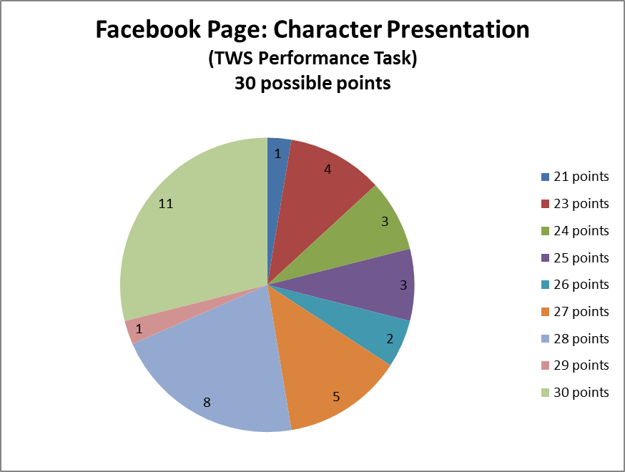

Summary of results from Performance Task:

The above pie chart highlights the scores which students received on their Facebook Page: Character Presentation assignment. The legend lists the scores; the numbers in the pie chart displays the number of students who received that score. Overall, the lowest score received was a 21/30, making the lowest percentage a 70%. No student received a grade lower than this score.

Over half of the class (66%) received a score above 90% with 29% receiving perfect scores. These are tremendous results. The sophomores were successful as a whole in putting their best efforts into the assignment.

I feel like the students were really able to excel in understanding Unit II’s concepts in this performance task. They were allowed to present the traits and practices of direct and indirect characterization, which were essential key ideas to the unit. Through this task, students were able to individually demonstrate their comprehension of the methods.

Examples of Facebook Page: Character Presentation (Performance Task):

- Example #1 – Caleb (profile of Miss Strangeworth from The Possibily of Evil)

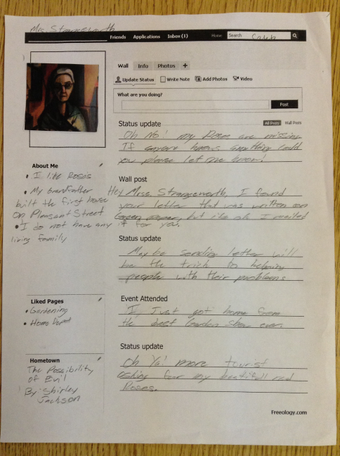
- Example #2 – Emma (profile of Bombur the Dwarf – The Hobbit, Classic novel)

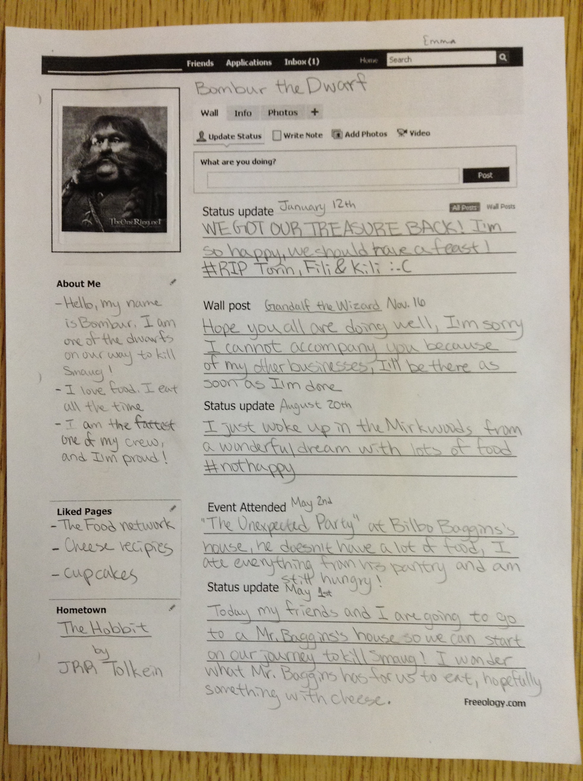

- Example #3 – Cheyenna (profile of Mattie from Shoofly Pie)

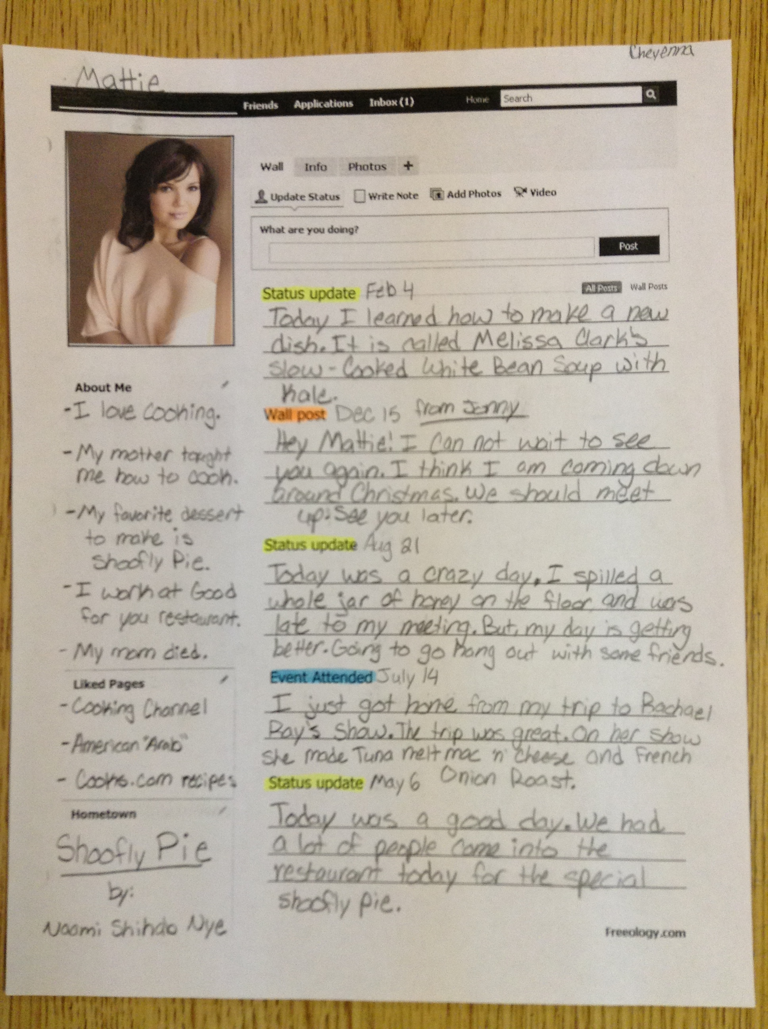

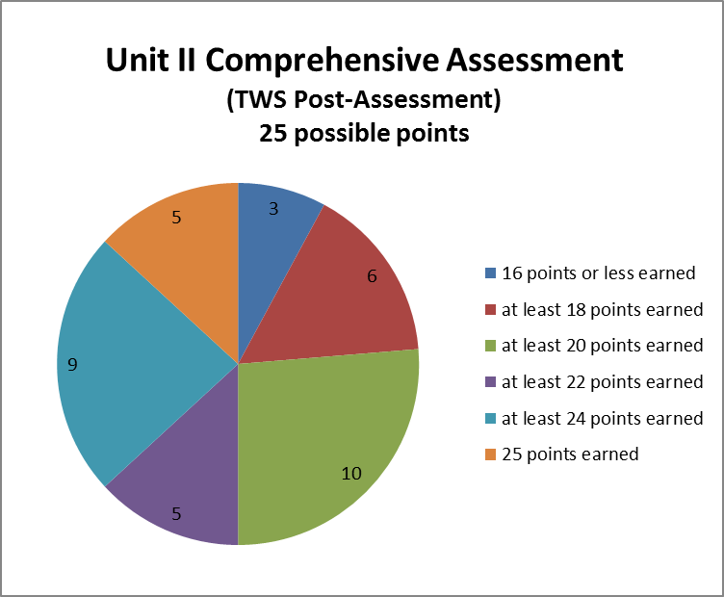

Summary of results from post-assessment:

The pie chart above illustrates the scores of the post-assessment that the students took after being taught the information from Unit II. The comprehensive assessment was a test constructed by myself which required the students to read excerpts from The Secret Life of Walter Mitty and answer questions pertaining to learned methods/techniques of characterization from Unit II; it was out of a possible twenty-five points. The numbers in the sections of the pie chart highlight the number of students that correspond with the points (note the legend) they earned.

The lowest score received in the class was a 14/25, making the lowest score percentage a 56%. However, if we calculate the largest areas of the chart, most of the students scored above 72% (18/25). From these results, we can gather that 92% of the sophomore class received a passing grade on the comprehensive assessment. 50% of the class received a grade of 88% or higher.

From this information, I was able to conclude that students had learned a substantial amount of information from my teaching in this unit. Not only did they build onto their prior knowledge (starting points of students reflected on in the data received from the post-assessment), most were able to demonstrate knowledge that delivered passing scores for the final. From these results, I can see that the sophomores were able to comprehend the assessment questions, apply what they knew about the concepts learned, and answer the questions with details about characterization that was reflected in The Secret Life of Walter Mitty story.

Reflection

Student Learning Progress

In comparing the pre-assessment and the post-assessment charts and data summaries included in the work sample above, students gained a large amount of knowledge from this unit of study.
- Before instruction, the lowest score percentage received was a 0% (0/18); from my collection of data after instruction, the lowest score percentage received was a 56% (14/25).
- Before instruction, the highest score percentage received was a 67% (12/18); from my collection of data after instruction, five students received the highest score, a 100% (25/25).
- The overall highest score was improved by 33%. If we look at the pre-assessment overall scores, students were significantly below 67%, the highest score, which is not a passing grade. However, the post-assessment shows that 92% of the class received a passing grade. This is a huge improvement.

Individually, I was pleased to see students who had done poorly on the pre-assessment excel in the post-assessment.
- Trevor, a boy from my fifth period, had received a 6% (1/18) on the pre-assessment; he received an 80% (20/25) on the post-assessment.
- Layne, a boy from my fifth period who has ADHD, had received a 39% (7/18) on the pre-assessment; he received a 92% (23/25) on the post-assessment (he refused to my coop to read him the post-assessment and completed the test on his own.)
- Brianna, who is assisted by a paraeducator, received a 0% (0/18) on the pre-assessment; she received a 56% on the post-assessment (both times just assisted with reading). This was an improvement, one in which I was proud to see Brianna meet.
- Madeline, a girl from my seventh period, received a 17% (3/18) on the pre-assessment; she received a 100% (25/25) on the post-assessment.

Besides the post-assessment, the performance task that the students completed reflected an understanding of applying their knowledge to a given task or situation. While it is good to know vocabulary terms and categorizing characters in their specific descriptions (round, flat, static, dynamic), it was beneficial for the students to display their characters using direct and indirect characterization techniques. The students were able to expand their ideas in the performance task instructions; it gave them ownership on individualized learning.

The unit objectives were met because students proved that they understood what character traits are involved in character development. They were able to interpret a character’s motivation, make inferences from the readings, and connect (relate) to situations that the characters faced in the unit. I was able to see that the unit objectives were met through discussions in class, the worksheets and activities assigned to the students, and the comprehensive assessment at the end of the unit. Most of the students showed that they improved individually in their work. While some students still struggled a little with vocabulary and applying the concepts, they were still able to meet the objectives through guided instruction. Through their completion of the Facebook Page: Character Presentation, students shaped their knowledge on characterization (direct and indirect) to highlight key traits of their chosen character. It is not only important to know the information; it is very beneficial to make sure that students are able to reflect and showcase their learning. This performance task was able to do just that.

There was no digression of score percentage in individual student results. I would like to mention that I felt like some students could have pushed themselves to do better in the post-assessment. For one, Tanner, who had received the highest score in the pre-assessment, 67% (14/18), received an 80% (20/25) on his post-assessment. I felt like while I saw good work from him throughout the unit, when he handed in his comprehensive assessment, his short answers were lacking in the quality I thought he’d include. I was more encouraged and proud of the students who I could see struggling (Amber, Araina, Alli, Bailey) than I was of students like Tanner who I knew could do better and evidently lacked the motivation to meet their full potential.

There were some negative factors that impacted learning in this unit. Because the Teacher Work Sample was to be completed in about seven days, I would argue that this unit could last longer. I would have liked to include more informational texts and selections to the unit so that the students were given more practice in identifying, discussing, and demonstrating their knowledge on characterization. More time would have been beneficial. Another negative factor was the boys in fifth period. It was hard to keep them on topic and motivated at times.

With negative factors, there were also positive factors that impacted this unit. My sixth and seventh period sophomore classes were focused groups. They liked to keep discussion going and stayed on task when given an assignment to work on. They weren’t afraid to ask questions if confused on information. I also believe that my good humor guided the students to pay attention in class.

If I were to teach this unit again, I would take more time (school days) to cover the material. I would possibly do a “self-reflection” characterization activity in which the students would study themselves to see what character traits they’d have if they were a character in a story. Another modification I would do is to readjust the comprehension assessment on The Secret Life of Walter Mitty. There were some students who were confused about the daydreams in the story (they thought they were flashbacks to his life). I would include a disclaimer at the beginning of the test to clear up confusion on this matter.

Personal Professional Growth

From this experience with my Teacher Work Sample, I learned a fair amount about student learning as well as the steps a teacher needs to go through in order to plan, construct, and organize a unit of teaching. I was able to see just how much time a teacher puts into lessons plans in order to confirm students’ interests, engagement, and growth in knowledge. By creating worksheets, activities, and assessments, I was able to reflect and critically think about what was expected of my students to understand. To keep the students motivated in class, I made sure to use a variety of teaching methods to keep them focused and involved. While specific students will pay attention and want to learn, there are other students who will cause disruptions and distractions while instruction is taking place. Building relationships with my students is also a top priority because the stronger the relationship, the easier it is to connect with them. With conversations and feedback from my coop, I was also able to learn how I can improve my lesson ideas to further accommodate the class’s needs.

Because of this experience, my perception of myself as a teacher has somewhat changed. I have realized that as a perfectionist, developing lesson plans and activities to meet the students’ needs and interests are definitely a personal priority in the classroom I’m teaching. While I knew this before, I didn’t realize just how important it is to me to make sure each of my students are prepared for learning. I have also realized that even though I strive to have an assertive teaching style, I still need work in achieving the level of appropriate disciplinary methods. I believe that because I am in someone else’s classroom, I hold back on calling out inappropriate behavior. Through this experience, however, I have found that praising a student for excellence in the classroom is an important part of my instruction. In order to encourage students, I feel it is essential to point out the positive events happening in the classroom as well as stopping the negative. Overall, this experience has pushed me to become a better teacher and has helped me in my preparation of becoming a professional educator.

