Table of Contents

Introduction/Context of Teaching………………………………………. 2

Understanding By Design Stage One ………………………………….. 3

Pre-assessment Worksheet …………………………………………………. 4

Pre-assessment Reflection ……………………………………………………5-7

Understanding By Design Stage Two ……………………………………. 8

Post-Assessment Rubric ………………………………………………………..9-10

Lesson Plans …………………………………………………………………………… 11-26

Reflections ………………………………………………………………………………. 27-33

Introduction

Student Teacher __Rachel Werner________________
Cooperating Teacher __Mrs. Julie Phillips______________
School __Our Redeemer Lutheran School __

Context of Teaching
For this Social Studies unit, I am teaching third, fourth, and fifth grades. There are seven third graders, three fourth graders, and five fifth graders. One student has an IEP, but he does not act like it at all. He is perfectly able to work in the class with the other students. There are a few members of the class, maybe about four, who have a hard time staying focused. Sometimes they will just tune out of the lesson or become distracted by something else in the classroom. Other students have a hard time staying on task, busy, and organized. They will forget the schedule and what they are supposed to be doing. One student in the class has a hard time working in general. He does not want to do anything and he does not care about anything either. His parents do not really make him do anything at home, which is also somewhat of a problem when we try to have him do something at school. I had some leeway with this project in that I could pick what I wanted to do. Mrs. Phillips asked that I do this unit as an ending project to the Southeastern region unit the students had been learning about in class up to this point. They are still currently going over some of the states, so the students will only have about ten minutes worth of class time at the end of class to work together in their groups. We will also give the students more time throughout the day to work on their projects, though, too. They will not just have the ten minutes at the end of the Social Studies period.

Understanding by Design Stage One
Stage 1 – Identify Desired Results

Established Goals:
4.7 Students will use higher level thinking processes to evaluate and analyze primary sources and other resources.
Source: http://www.education.ne.gov/ss/
4.2.2 By the end of the fourth grade, students will write paragraphs/reports with focus, related ideas, and supporting details.
4.3.2 By the end of the fourth grade, students will deliver organized oral presentations using complete sentences, clear enunciation, adequate volume, and eye contact.
Source: http://nlcs1.nlc.state.ne.us/epubs/E2000/R056-2001.pdf

What understandings are desired?
Students will understand that.
- Over-arching U: … how to evaluate and use a good source when researching.
- Topical U: … using the information found to write a paper.
- Topical U: … presenting the information found is part of learning.

What essential questions will be considered?
- Over-arching Q: What is the value in evaluating and using a good source when researching?
- Topical Q: How do you use the information found in research to write a paper.
- Topical Q: Why do we present our information to the class?

What key knowledge and skills will students acquire as a result of this unit?
Students will know. . .
What a good source looks like.
How to work together in a group.
How to write a paper.
Some interesting facts about the state they researched.
How to keep a resource list.
Students will be able to. . .
Work together to conduct a presentation to the class.
Write a paper.
Describe their state’s flag and symbols.
Research their states and find accurate information from good sources.
Keep a resource list of the sources they used when researching.

Pre-Assessment

What Do You Think You Know?
On the following questions, I would like for you to rate yourself on what you know or what you think you know. This is not a test; it is just for me to see where you see yourselves before we start our project. Please circle the number you feel shows what you know. A 10 means you feel confident about the subject and you could do anything with it, but a 1 means you don’t know anything about it and you need help. Both answers are fine. Thanks!
- I feel I can search for information in an encyclopedia.
1 2 3 4 5 6 7 8 9 10
- I know which websites have accurate information on the internet.
1 2 3 4 5 6 7 8 9 10
- I know how to search for information on the internet.
1 2 3 4 5 6 7 8 9 10
- I know how to write a paper using all the correct grammar and spelling.
1 2 3 4 5 6 7 8 9 10
- I know what a bibliography is and how to write one.
1 2 3 4 5 6 7 8 9 10
- I know how to work together in a group and can contribute to a project.
1 2 3 4 5 6 7 8 9 10
- I know all the states in the Southeast region.
1 2 3 4 5 6 7 8 9 10
- I know some facts about all the states in the Southeastern Region.
1 2 3 4 5 6 7 8 9 10
All the questions were based on a rating scale of 1 to 10. The following is the analysis of the whole class.
 | Rate 1 | Rate 2 | Rate 3 | Rate 4 | Rate 5 | Rate 6 | Rate 7 | Rate 8 | Rate 9 | Rate 10
Question 1 | 2 | 1 | 0 | 2 | 3 | 1 | 1 | 0 | 1 | 3
Question 2 | 5 | 0 | 1 | 0 | 1 | 0 | 2 | 1 | 3 | 1
Question 3 | 0 | 2 | 0 | 0 | 3 | 0 | 0 | 0 | 0 | 9
Question 4 | 2 | 0 | 1 | 0 | 0 | 5 | 1 | 2 | 1 | 2
Question 5 | 8 | 1 | 1 | 0 | 3 | 0 | 0 | 1 | 1 | 0
Question 6 | 0 | 0 | 0 | 1 | 1 | 1 | 0 | 5 | 2 | 4
Question 7 | 2 | 1 | 2 | 1 | 0 | 3 | 3 | 1 | 1 | 0
Question 8 | 0 | 1 | 1 | 2 | 4 | 1 | 2 | 1 | 1 | 1

Most students did not feel they knew how to research using an encyclopedia. I decided for the sake of time to allow the students to just use the internet instead of trying to find encyclopedias. Each student would be able to have access to the internet anyway. I found that I will have a short lesson on finding information on the internet and on what sources would be labeled as a good source of information. Most students indicated they do not feel they would be able to know what makes a good source. That would be a good topic to go over, especially with a research paper.
A good amount of the students indicated they felt fairly confident in writing a grammatically correct paper. I know the class writes papers for Mrs. Phillips, so I think they will do fine. I will, however, give the students a few tips about the use of grammar in a paper during one of the classes.
Through this pre-assessment piece, I learned that many students do not know anything about bibliographies. From this information, I knew that I needed to teach them about bibliographies and what they were. Instead of actually writing a bibliography, though, I found that it would be more beneficial to the class and the amount of time I have to teach, to just teach the students how to write a resource list instead. Some students indicated they knew what a bibliography was, but I believe that writing a resource list will be just as beneficial and they will learn that they need to recognize the source in which they get their information.
I found it interesting that many students indicated they did not know many of the states or some facts about the states in the region since they have been going through the states in Social Studies. I think this project will help them remember the states better as a whole.

Next are the results of the children as they rated themselves individually to the same questions asked before and on the same scale of 1 to 10.
Name | Question 1 | Question 2 | Question 3 | Question 4 | Question 5 | Question 6 | Question 7 | Question 8
Child 1 | 4 | 1 | 2 | 1 | 2 | 8 | 3 | 5
Child 2 | 4 | 7 | 10 | 6 | 5 | 8 | 1 | 3
Child 3 | 5 | 1 | 10 | 6 | 1 | 5 | 9 | 7
Child 4 | 5 | 7 | 10 | 8 | 1 | 10 | 7 | 6
Child 5 | 5 | 9 | 5 | 3 | 3 | 4 | 2 | 10
Child 6 | 9 | 9 | 10 | 10 | 1 | 10 | 6 | 5
Child 7 | 2 | 1 | 2 | 6 | 1 | 8 | 4 | 4
Child 8 | 1 | 5 | 10 | 1 | 1 | 6 | 1 | 5
Child 9 | 1 | 1 | 5 | 6 | 1 | 8 | 3 | 4
Child 10 | 7 | 10 | 10 | 7 | 5 | 8 | 7 | 7
Child 11 | 6 | 8 | 10 | 9 | 5 | 10 | 8 | 2
Child 12 | 10 | 3 | 5 | 6 | 1 | 9 | 6 | 8
Child 13 | 10 | 9 | 10 | 8 | 8 | 9 | 7 | 9
Child 14 | 10 | 1 | 10 | 10 | 1 | 10 | 6 | 5
Child 15 | 7 | 5 | 10 | 4 | 1 | 10 | 3 | 3

Through this pre-assessment piece, I was able to see what each child thinks they are able to do as well as just looking at the class as a whole. Child number one does not seem to think he knows a great deal about the research part of the project, but he feels as though he can work together with others and knows a bit about the region. I thought this was interesting because this child is actually one of the students I was going to have to watch about the group work. I will try to explain how to research for information to help this child.
Child number two seems to believe he/she understands the research part of the project more than remembering the states and facts about the region. I thought that was curious because the class has been going through the Southeast region for the past couple of weeks.
Child number three gave him/herself fairly high marks except for knowing how to find accurate information on the internet and knowing about a bibliography. I will be going over these topics in class. Children numbers four, five, and six also rated their understanding of the topics fairly high except for the bibliography topic. Child number seven rated his/herself pretty low on the scale. I think that might be this child’s personality, though, too. I can see much of the low rating shows the child needs help most in the research area. The next child, number eight, had a few ones in his/her ratings. One of the topics that really got me was the grammar and spelling for writing the paper. I know the class has written papers before, but I will touch on writing a paper in class. I also wrote out some questions for the students to write about in their papers. This will help them know what I am looking for and help them think things through about what they are writing about. Child number nine had a few ones, but I will be touching on the topics he/she said they felt they were not comfortable with. Children ten and eleven both gave themselves fairly high ratings in everything including the bibliography. That was somewhat of a surprise since most of the other children did not know what that was at all. Child number twelve also gave everything except the bibliography which I will be going over in class. Like children ten and eleven, child number thirteen rated him/herself fairly high in everything as well. Child number fourteen had a few tens, but also a couple ones. The ones will be covered in class to help the student. The last child, number fifteen, had trouble understanding the bibliography. This student, though, also does not feel as confident about the states and regional facts.
I think much of this rating the students did shows how the students look at themselves as well. If the student is naturally confident, then the student will most likely give themselves a fairly high score. If the student does not see themselves as highly, then they probably will not rate themselves as high either. Overall, though, I was able to take these results and know what subjects and topics I should go over more in class and which subjects I do not need to go over as thoroughly. I think I will need to go over how to search for information on the internet, how to write a resource list, how to work together as a group, and how to write a grammatically correct paper. These are all areas that based on the pre-assessment many students do not feel very confident in. I also found that no one feels very comfortable writing a bibliography. Based on this information, I decided, with the aid of my cooperating teacher, to instead start the students off with writing a resource list. This is still having the students become aware of the resources they are using in their projects, but it is a step below a bibliography. Based on the amount of time we will have for this unit, I thought teaching the students about a bibliography would not be a great use of the time. A resource list would be a nice beginning step before the students need to learn about writing bibliographies. The pre-assessment was also helpful to show what each of the students thought they were able to do. What the student thinks sometimes shows through what they do.

Understanding by Design Stage Two
Stage 2 – Determine Acceptable Evidence

What evidence will show that students understand?
Goal: 4.7 Student will use higher level thinking processes to evaluate and analyze primary sources and other resources.
Source: http://www.education.ne.gov/ss/
4.2.2 By the end of the fourth grade, students will write paragraphs/reports with focus, related ideas, and supporting details.
4.3.2 By the end of the fourth grade, students will deliver organized oral presentations using complete sentences, clear enunciation, adequate volume, and eye contact.
Source: http://nlcs1.nlc.state.ne.us/epubs/E2000/R056-2001.pdf
Role: The children will participate in a partnership of learning and researching about the state they are assigned.
Audience: The children will present their projects to the entire class and the teachers.
Situation: The children will participate in researching a state with partners to learn further details about one state, writing a paper about the state, and then presenting a project about the state to the class.
Performance: The children will work together to research and create a project that is uniquely about the state, write a paper about the state, and present their projects to the class.
Standards: Rubric

Other Evidence
Observation during class
Informal assessment from pre-assessment worksheet
Informal assessment of writing the paper
Informal assessment of class presentation

Student Self-Assessment and Reflection:
What did you learn from this unit?
What did you find hard?
What was your favorite part?
What can I do better next time?

Post-Assessment

State Project Rubric Group Name __________________________

 | Advanced  4 | Proficient  3 | Nearing Proficiency  2 | Novice  1
Researching | Showed thorough understanding of how to find a good and accurate resource. | Almost all information used was found by an accurate resource. | Most of the information used was found by an accurate source. | Needs work with finding accurate sources.
Group Work | Worked hard and stayed on task through the whole project. Everyone contributed to the project. | Almost always worked hard and stayed on task through the whole project. Everyone contributed to the project. | Worked hard and stayed on task most of the time. Most members contributed to the project. | Needs work staying on task and working hard on the project. Not all members contributed to the project.
Written Paper | Few grammatical and spelling errors. Answered all the questions and had 4 sentences per paragraph. Included a Resource List. | Few grammatical and spelling errors, but did not answer all the questions. Included 4 sentences per paragraph and had a Resource list. | Several grammatical and spelling errors. Included Resource List. Did not answer all questions and did not include 4 sentences per paragraph. | Several grammatical and spelling errors. Did not include a Resource List. Did not answer all questions nor did it include 4 sentences per paragraph.
Presentation | Showed creativity and depth in their understanding of their state. Presentation was obviously practiced.  All members contributed. | Mostly showed understanding of the state. All members contributed, but the presentation could have been smoother. | Showed some understanding of state. Not all members contributed. The presentation was not well rehearsed. | Showed little understanding of state. Not all members contributed. The presentation was noticeably not rehearsed. The students had no idea what to say.
Project | Showed creativity and hard work on the project. Connects well with the state. | Showed creativity. Project connects with the state. Worked fairly hard on project. | Showed some creativity. Did not work hard on the project. Showed some connection with the state. | Showed little creativity. Did not work hard on the project. Did not connect well with the state.
Comments:

Lesson Plans
Student Teacher: Rachel Werner Grade Level: 3-5 Date: 9/12/13
State Standard: 4.7 Student will use higher level thinking processes to evaluate and analyze primary sources and other resources.
Source: http://www.education.ne.gov/ss/
4.2.2 By the end of the fourth grade, students will write paragraphs/reports with focus, related ideas, and supporting details.
4.3.2 By the end of the fourth grade, students will deliver organized oral presentations using complete sentences, clear enunciation, adequate volume, and eye contact.
Source: http://nlcs1.nlc.state.ne.us/epubs/E2000/R056-2001.pdf Subject: Social Studies
Name of Lesson: Southeastern Region Day 1 Period / Time: 20 minutes
I. Goal:  The goal of this lesson is to teach students how to evaluate a source. | Required Adaptations/Modifications:
II. Objectives:  Students will be able to describe what the project entails.  Students will be able to evaluate a source when researching. | Required Adaptations/Modifications:
III: Faith / Values Integration:  Have option to research religion and Lutheran schools in state. | Required Adaptations/Modifications:
IV. Integrated Technology:  Ipads | Required Adaptations/Modifications:
V. Materials:  Pre-assessment worksheets, Bubble maps, Student checklists and explanation of project | Required Adaptations/Modifications:
VI: Procedure:  A. Set / Hook: What region are we learning about right now? What states are included in that region? I’m handing out a worksheet I’d like for you all to fill out for me. It’s just to see what you know; I won’t be grading it or anything.  B. Transition: For the next few class periods, we are going to be researching in more detail about the states of this region.  C. Main Lesson: Talk about Research and Sources:  - Who knows anything about researching for information? Have any of you done any researching before? How about when you have to search the news for your current event? That’s actually researching.  - Where do you look for your current events? Why there? Is that a good place to look for that information? Why? How do we know that’s accurate information?  - Newspapers usually report accurate information because many times the journalists were there or interviewed people who were there at the event being written about. That’s called a primary source when someone is there. Those are really good sources.  - Have any of you ever used an encyclopedia? Those are good sources for information, too. Why? They had to be reviewed by many people before printing.  - How about the internet? Who has used the internet to find something before? Are all the things on the internet true? No! How can we tell if the information on the internet is true?  - Try to use sites that have .gov or .edu. What do those sites stand for?  - Don’t use any Wikipedia sites. Why do I say that? People can get on the internet and change information very easily.  - You can try to see if your state has a website. That would be a great place to look for accurate information. Why?  - I split you all into groups of 2 with one group of 3. You each get a state from the southeast region.  - Hand out checklists and directions about project.  - Go through the sheets.  - These sheets are for you to keep and use as a reference throughout the project.  - Tell them their partners and states.  - If time allows, let the students get together with their partners to talk about their projects.  D. Transition: Congratulate students on their progress and understanding of the project.  E. Conclusion: I will ask them to please put everything away and be thinking about what you want to do with your partner about the state. Remember, you will only be given about 10 minutes each day to work with your partner on the project. Use your time wisely. You might even want to split some of the project up between the two of you if you don’t think you’ll have enough time. | Required Adaptations/Modifications:  Provide checklists for the children who have a hard time remembering what needs to be done next.  Directions both on paper and spoken will help both the auditory and visual learners.  Tell the students to write the date the assignments are due so they will remember.
VII. Assessment:  What makes a source accurate?  Are any sources or websites accurate?  How can we tell if a source is accurate? | Required Adaptations/Modifications:
VIII. Assignment:  Get together with their partners and come up with ideas for the project. | Required Adaptations/Modifications:
IX. Self-Evaluation:  I thought it went fairly well. I should probably have written out on sheets or provided a place on the directions for the students to write their partner’s name and which state they were to do. I think the children were actually attentive and responsive, which does not always happen. They made my lesson a great deal easier for me to teach. We went a little over the time because we didn’t start quite at the exact time we were supposed to. I think it still was fine and I think I handled it fairly well. | X. Coop’s Comments:  Comments at the end.

Student Teacher: Rachel Werner Grade Level: 3rd – 5th Date: 9/18/13
State Standard: 4.7 Student will use higher level thinking processes to evaluate and analyze primary sources and other resources.
Source: http://www.education.ne.gov/ss/
4.2.2 By the end of the fourth grade, students will write paragraphs/reports with focus, related ideas, and supporting details.
4.3.2 By the end of the fourth grade, students will deliver organized oral presentations using complete sentences, clear enunciation, adequate volume, and eye contact.
Source: http://nlcs1.nlc.state.ne.us/epubs/E2000/R056-2001.pdf
Subject: Social Studies
Name of Lesson: Southeastern Region Day 2 Period / Time: 50 minutes
I. Goal:  The goal of this lesson is to teach students how to search for information on the internet. | Required Adaptations/Modifications:
II. Objectives:  Students will be able to type key words into the search engine.  Students will be able to use a search engine.  Students will be able to describe some characteristics of Tennessee. | Required Adaptations/Modifications:
III: Faith / Values Integration:  Students have the opportunity to research religion in their state. | Required Adaptations/Modifications:
IV. Integrated Technology:  IPads/computers, ELMO | Required Adaptations/Modifications:
V. Materials:  Tennessee worksheets, Ipads/computers, ELMO, Bubble maps, Sources sheet, suggested schedule | Required Adaptations/Modifications:
VI: Procedure:  - Set / Hook: What are some of the states we’ve learned about in the past couple weeks? Does anyone know where the country music capitol is in the United States? Tennessee is the state we are going to be talking about today!  - Hand out Tennessee worksheet.  - Go through the worksheet provided.  - Have any of you heard of Davey Crockett? Can you believe he was a member of Congress if you just see his picture? (10 minutes)  B. Transition: So, if we were to look up Tennessee, what kinds of resources would be good to use? (45 seconds)  C. Main Lesson: Today we’re talking about search engines and where to look when searching for information on the internet.  - Get out the ipad and use the ELMO to project what you are trying to show the students off the screen.  - Go to the search engine and we will be using the Big Blue E.  - In the search engine, you can type in your state and a key word that you are looking up.  - Does anyone know what I mean by key word?  - Since no one was assigned Florida, we’ll look up FL for right now.  - What was one of the topics we were supposed to find about FL?  - We were supposed to find out about FL’s flag so we can type in “history behind FL’s flag” into the search engine and hopefully we’ll find something about FL.  - When you find information in a website, though, make sure you write down the website’s name and the address you find up at the top of the browser. You can copy that information down onto your resource sheet. I’m going to hand out. Why do you think we need to show where we found our resources?  - Hand out Resource sheet, Bubble Maps, and Suggested Schedule  - Use the bubble maps for notes about information about your state. For example, write down the landmark and descriptions. You can use this to help with your notes to write your paper.  - Use the suggested schedule to keep on top of getting everything done. There is a great amount of things involved with this project, so it would be a good idea to space them all out.  - Keep these sheets in a place where you will not lose them, like in your S.S. folder.  - Give students time to work together on their project  - Monitor the students’ working together by circulating around the room. Make sure the children are staying on task and are focused.(36 minutes)  D. Transition: Congratulate students on their hard work in understanding how to search for information on the internet. (15 seconds)  E. Conclusion: Please put everything back away and get ready to go home. Put the iPads back on Mrs. Phillips’ desk and put your papers away. Please remember that you may work more on this during Free Explore tomorrow if you’d like. Try to figure out what kind of a project you’re going to do for the presentation. I would like to know by tomorrow what you plan on doing. Also don’t forget that on Friday, you will be given class time during Art to work on your projects. Bring any supplies you may need to work on them. If you’re cooking, you should be researching for your paper at this time. (3 minutes) | Required Adaptations/Modifications:  The Bubble map will help organize the students which will help them when writing.  The Source List will help the students keep track of the sources they use.  The Suggested Schedule will help the students stay on track and keep organized. Some students have a hard time spacing out what they should have done and when they should have it done. This will hopefully help those students stay focused and on task.
VII. Assessment:  What is a search engine?  What are some key words to help you find information on the internet?  Which sites are good sites to look at? | Required Adaptations/Modifications:
VIII. Assignment:  Figure out your project choice | Required Adaptations/Modifications:
IX. Self-Evaluation:  I thought the lesson went fairly well. The students continue to amaze me with what they know that I had not even begun to think about. The children knew that they needed to show where they found their information in case they wanted to go back to the source later. Some did not know how to get on the internet, but were learning. I had some difficulties with the technology for this lesson, but the substitute teacher and the teacher from the younger grades classroom came in and helped me get things going with the ELMO projector. Other than that, I think the lesson itself went fairly smooth. Looking back, I maybe should not have asked the students to write and research such a long paper. It will be tough to get the students to focus on not just doing their projects, but also researching for their paper. | X. Coop’s Comments:  Comments at the end.

Student Teacher: Rachel Werner Grade Level: 3rd – 5th Date: 9/24/13
State Standard: 4.7 Student will use higher level thinking processes to evaluate and analyze primary sources and other resources.
Source: http://www.education.ne.gov/ss/
4.2.2 By the end of the fourth grade, students will write paragraphs/reports with focus, related ideas, and supporting details.
4.3.2 By the end of the fourth grade, students will deliver organized oral presentations using complete sentences, clear enunciation, adequate volume, and eye contact.
Source: http://nlcs1.nlc.state.ne.us/epubs/E2000/R056-2001.pdf
Subject: Social Studies
Name of Lesson: Southeastern Region Day 4 Period / Time: 10 minutes
I. Goal:  The goal of this lesson is to teach students about writing a paper. | Required Adaptations/Modifications:
II. Objectives:  Students will be able to write a topic sentence.  Students will be able to describe certain grammatical characteristics used in writing a paper such as indenting paragraphs.  Students will be able to write complete sentences. | Required Adaptations/Modifications:
III: Faith / Values Integration:  Students may write and research about the religion and Lutherans in their state. | Required Adaptations/Modifications:
IV. Integrated Technology: | Required Adaptations/Modifications:
V. Materials:  Ipads/computers | Required Adaptations/Modifications:
VI: Procedure:  A. Set / Hook: How many of you have already started your rough draft to your paper? (10 seconds)  B. Transition: I just wanted to go over some quick tips about grammar. (5 seconds)  C. Main Lesson: You all know what complete sentences are because we have been talking about them in grammar class.  - Call on someone and ask what a complete sentence is. What do complete sentences end with?  - Topic sentences- Each paragraph should start with a topic sentence. What is a topic sentence?  - It should give a short summary of what they will be talking about in the paragraph.  - Indenting paragraphs- The first sentence of each paragraph should be indented. All other lines after this first line, though, should start at the very edge of the paper. They are not supposed to be indented, only the first line.  - Remember that you need to have someone proofread your rough draft before writing your final copy.  - If you haven’t already started your paper, you really should be getting started on that very soon.  - Give children time to work in groups.  - Monitor their progress and observe their working together by circulating around the room. (8 minutes, 35 seconds)  D. Transition: Congratulate students on their hard work and their understanding of grammar in relation to writing a paper. (10 seconds)  E. Conclusion: Please put everything back where it belongs. If you have ipads out, please put them back on Mrs. Phillips’ desk. Put all your papers away back in your social studies folder. By Thursday, all of you should be able to start writing your papers. You should also have already started your projects by now. When are the presentations again? (1 minute) | Required Adaptations/Modifications:  Offer to help students proofread their papers.  Students may decide to use the computer instead of an ipad to complete their research or typing their paper.  Offer typing the report as an option, especially for those students whom have trouble writing.  Go to each group and look over their report before it is finished to see how they are doing and if they understand the grammatical concepts.
VII. Assessment:  When do we indent sentences?  What are topic sentences?  What are complete sentences and how do they end? | Required Adaptations/Modifications:
VIII. Assignment:  Start writing the papers. | Required Adaptations/Modifications:
IX. Self-Evaluation:  The lesson went well. I am glad that I was able to know beforehand that many of the students did not really know how to write a paper so I was prepared to assist them with that. Since so many of the students had not ever written a paper, I decided not to go too far into writing. I gave them the basics of what I was looking for and especially emphasized the need to work together as a group to complete the paper. Some students did not seem to fully grasp this point since many of them still thought they were supposed to each write a paper individually. I think I should have stated that more clearly at the beginning of the unit that this was all supposed to be with partners. Some students had already started their papers by this time, but others were still working on research. I had to really stop and help the students researching to stay on task and work together. Again, I maybe should have tried to specifically call attention to the fact that the students should be researching the topics for their paper, not just interesting facts about their state. | X. Coop’s Comments:  Comments at the end.

Student Teacher: Rachel Werner Grade Level: 3rd – 5th Date: 9/26/13
State Standard: 4.7 Student will use higher level thinking processes to evaluate and analyze primary sources and other resources.
Source: http://www.education.ne.gov/ss/
4.2.2 By the end of the fourth grade, students will write paragraphs/reports with focus, related ideas, and supporting details.
4.3.2 By the end of the fourth grade, students will deliver organized oral presentations using complete sentences, clear enunciation, adequate volume, and eye contact.
Source: http://nlcs1.nlc.state.ne.us/epubs/E2000/R056-2001.pdf
Subject: Social Studies
Name of Lesson: Southeastern Region Day 5 Period / Time: 10 minutes
I. Goal:  The goal of this lesson is for the students to work together quietly on their projects. | Required Adaptations/Modifications:
II. Objectives:  The students will be able to work together in a group.  The students will be able to quietly communicate to each other what they are doing. | Required Adaptations/Modifications:
III: Faith / Values Integration:  Students may write and research about the religion and Lutherans in their state. | Required Adaptations/Modifications:
IV. Integrated Technology:  Ipads/computers | Required Adaptations/Modifications:
V. Materials:  Ipads/computers, “Where are you at?” sheet | Required Adaptations/Modifications:
VI: Procedure:  A. Set / Hook: How is everyone coming along on their projects? (15 seconds)  B. Transition: I will be going around to each of the groups to ask you what you have done so far. (10 seconds)  C. Main Lesson: Everyone needs to work together quietly and attentively in a group. Is everyone still working together as a team or are some people letting their partners do all the work? Remember, you are each being graded on your own effort. It’s not fair to have one person work harder than all the others and everyone in the team get the same grade.  - Everyone gets together in partners and quietly works on their project.  - I will monitor the progress around the room. Checking in on all the groups to see how they are doing. (7 minutes, 25 seconds)  D. Transition: Congratulate the students on their hard work and good team work. (10 seconds)  E. Conclusion: Please put everything back where it belongs. How do you think you did at working as a team today? What could be done differently next time? If you are not done with your paper today, you better finish it over the weekend. Figure out how you are going to finish it by getting together or each write a paragraph and getting together on Tuesday to write it in the final draft form. Tuesday is the last day you will have to finish your projects. Really, Tuesday should be the day you go over what you are going to say in class and work on the finishing touches of your project. (2 minute) | Required Adaptations/Modifications:  The “Where Are You At?” sheet should help the students and me to see how well the students are using their time.  Offer some students a little more time during recess, after school, or some other subject to work on their project if they need more time and help.  If some groups need more quiet than is offered in the classroom, allow the students to go down to the library, but make sure to check on them throughout the period.
VII. Assessment:  How are you working together as a group?  How can you work better together next time? | Required Adaptations/Modifications:
VIII. Assignment  Finish writing the paper. | Required Adaptations/Modifications:
IX. Self-Evaluation:  We talked about group work and how each member needed to contribute to the group. I think, overall, the students are showing this understanding. The groups were working hard together and one group even finished their paper. They are now able to work on what they will say during their presentation. The other groups are still working on researching their states and writing their rough drafts. Again, I think I should have made it clearer in the beginning that they should be researching the specific topics for their paper and not just interesting facts. I tell one of the groups this each time and each time they act very surprised that there are actually specific topics they are to be researching. They were still on the researching and note taking steps by the end of the class period today. They are going to get together this weekend to work on the paper. All the other groups had at least started writing their papers. I thought most of the groups did work well together. They understand more about their state and how to find the information about their state, which is really the important part. | X. Coop’s Comments:  Comments at the end.

Student Teacher: Rachel Werner Grade Level: 3rd – 5th Date: 10/1/13
State Standard: 4.7 Student will use higher level thinking processes to evaluate and analyze primary sources and other resources.
Source: http://www.education.ne.gov/ss/
4.2.2 By the end of the fourth grade, students will write paragraphs/reports with focus, related ideas, and supporting details.
4.3.2 By the end of the fourth grade, students will deliver organized oral presentations using complete sentences, clear enunciation, adequate volume, and eye contact.
Source: http://nlcs1.nlc.state.ne.us/epubs/E2000/R056-2001.pdf
Subject: Social Studies
Name of Lesson: Southeastern Region Day 6 Period / Time: 10 minutes
I. Goal:  The goal of this lesson is for students to work together quietly in a group. | Required Adaptations/Modifications:
II. Objectives:  Students will be able to work together to finish their projects.  Students will be able to manage their time to rehearse what they will say for their presentation. | Required Adaptations/Modifications:
III: Faith / Values Integration:  Students may write and research about the religion and Lutherans in their state. | Required Adaptations/Modifications:
IV. Integrated Technology:  Computers and iPads | Required Adaptations/Modifications:
V. Materials:  Any materials needed for projects, papers | Required Adaptations/Modifications:
VI: Procedure:  A. Set / Hook: How many of you are finished with your projects? How many are finished writing your papers? (30 seconds)  B. Transition: When I say, I want all of you to get up and go to your partner to work on your project. (10 seconds)  C. Main Lesson: Remember this is the last time you will have to work on the project together in class. If you do not finish today, you will have to find time to get together outside of class to work on it. How are you to work together today? (As a group, being quiet and focusing on our task.) Please try to rehearse what you will say and do during your presentation as well. You do not want to get up in front of everyone on Thursday and not know what you’re going to say.  - Give children time to work on the finishing details.  - Go to each group and check on how well they are doing together and monitor their progress. (8 minutes, 10 seconds)  D. Transition: Congratulate the students on their hard work. (10 seconds)  E. Conclusion: Please put everything away. How did you think it went today working in a group? Did everyone contribute? Thursday is the day for presentations. What are you supposed to have done? (Paper, project, and something to say.) How long is the presentation supposed to take? How many people are supposed to be a part of the presentation? (1 minute) | Required Adaptations/Modifications:  Offer assistance to groups that are having a harder time writing their papers.  If the papers are unreadable, offer the students opportunity to type them on the computer.  If students need an area to practice their presentation, allow them to go to the library, basement, or some other quiet area that is not being used at that moment. Make sure to check on them, though.
VII. Assessment:  Is everyone ready for the presentation Thursday?  What else do you need to do?  Did everyone help contribute to the project today? | Required Adaptations/Modifications:
VIII. Assignment:  Rehearse your presentations and what you will say. | Required Adaptations/Modifications:
IX. Self-Evaluation:  The students really worked hard on their projects today. Many of them really worked as a group and tried hard to finish their papers, especially. Some of the children seemed to just realize that they are supposed to be presenting on Thursday even though we had been discussing that for the past 3 weeks. This realization that the project and paper were both due in 2 days seemed to push the students into working harder. I think that they did a very nice job as working together as a team, which is what I was looking for with this lesson today. All of the students were at least working on their rough draft of their paper. Many of them were discussing when they could get together with each other after school to finish the projects and papers. They were taking the responsibility which is another aspect that I was hoping to inspire in these children. | X. Coop’s Comments:  Comments at the end.

Student Teacher: Rachel Werner Grade Level: 3rd – 5th Date: 10/3/13
State Standard: 4.7 Student will use higher level thinking processes to evaluate and analyze primary sources and other resources.
Source: http://www.education.ne.gov/ss/
4.2.2 By the end of the fourth grade, students will write paragraphs/reports with focus, related ideas, and supporting details.
4.3.2 By the end of the fourth grade, students will deliver organized oral presentations using complete sentences, clear enunciation, adequate volume, and eye contact.
Source: http://nlcs1.nlc.state.ne.us/epubs/E2000/R056-2001.pdf
Subject: Social Studies
Name of Lesson: Southeastern Region Day 7 Period / Time: 50 minutes
I. Goal:  The goal of this lesson is to offer students opportunity to enhance their oral speaking skills. | Required Adaptations/Modifications:
II. Objectives:  Students will be able to speak clearly and with good speed through the presentation.  Students will be able to demonstrate good teamwork.  Students will be able to describe their projects in a timely manner. | Required Adaptations/Modifications:
III: Faith / Values Integration:  Students may write and research about the religion and Lutherans in their state. | Required Adaptations/Modifications:
IV. Integrated Technology:  Ipads/computers | Required Adaptations/Modifications:
V. Materials:  Projects, papers, rubric, pencil/pen, list of order to present | Required Adaptations/Modifications:
VI: Procedure:  A. Set / Hook: Before we get started, I just wanted to thank you all for your hard work and great attitudes when you started this project. You went above and beyond. (1 minute)  B. Transition: So, do I have any volunteers to go first? (30 seconds)  C. Main Lesson: Students present their projects.  - Ask if there are any questions after presentation.  - Clap at the end  - Follow the rubric and pay close attention to whether everyone contributes to the presentation. (45 minutes)  D. Transition: Congratulate the students on finishing their projects and having such wonderful presentations. (30 seconds)  E. Conclusion: Please put your projects, if you have any, on the back table. I will be looking at your projects tonight and tomorrow. I will hopefully have everything graded by next week. Great job everyone! (3 minutes) | Required Adaptations/Modifications:  Allow students time to set up their projects and explain what they did. If the student brought the supplies to make the project during the presentation, allow extra time.  Help the students with what to say if needed. Give prompts and questions about the state to help any students who may forget what they are to say.
VII. Assessment:  How does your project relate to your state?  How did everyone contribute to the project and presentation? | Required Adaptations/Modifications:
VIII. Assignment:  Nothing | Required Adaptations/Modifications:
IX. Self-Evaluation:  The students did a great job with their presentations. They all were ready and handed everything in on time, which made me so proud of them. I probably should have been a little more prepared in the way of setting everything up to run a little smoother. I should have made sure everyone had their projects in the room and ready to present instead of wasting time having kids find their food and projects in the hall or in the kitchen. It did get better as the day went on, though, that I realized this and had the kids from the next group go find their things while a different group who already had their project started to present. That worked a lot smoother. I was not 100 percent sure how to grade using the rubric and I realized that as I was trying to grade and listen to the presentations. It was hard to watch, grade, and help move the presentations along all at the same time. I think as I use rubrics more, I will be able to better handle the situation of grading the work and keeping the class on task. | X. Coop’s Comments:  Comments at the end.

The following are some of my students presenting their projects.
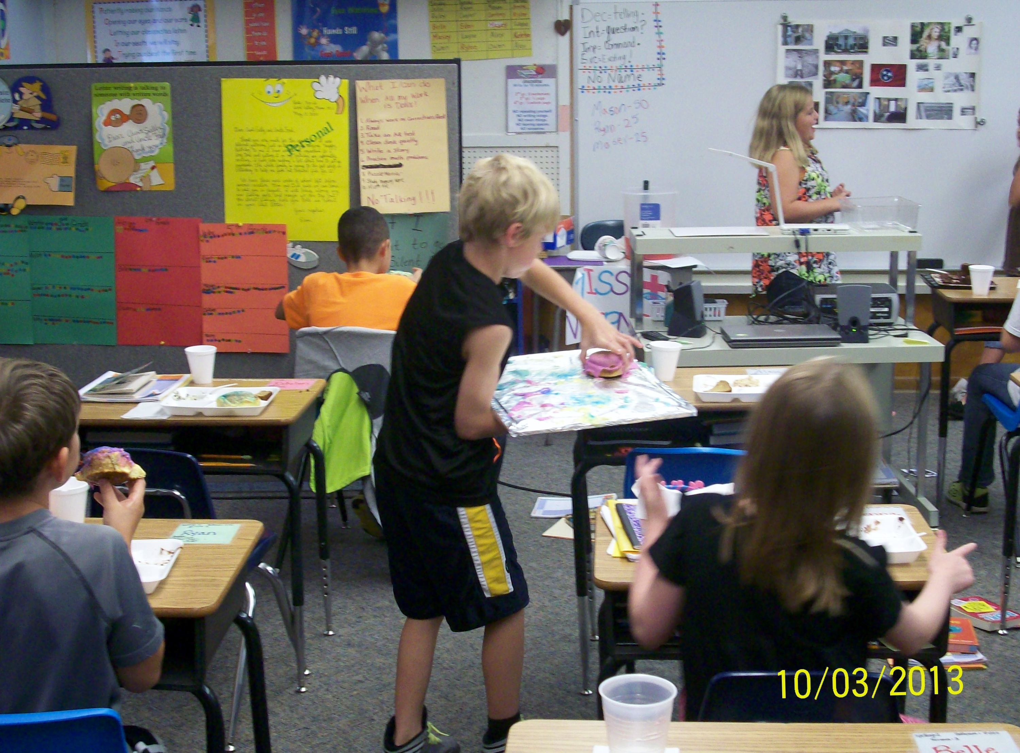
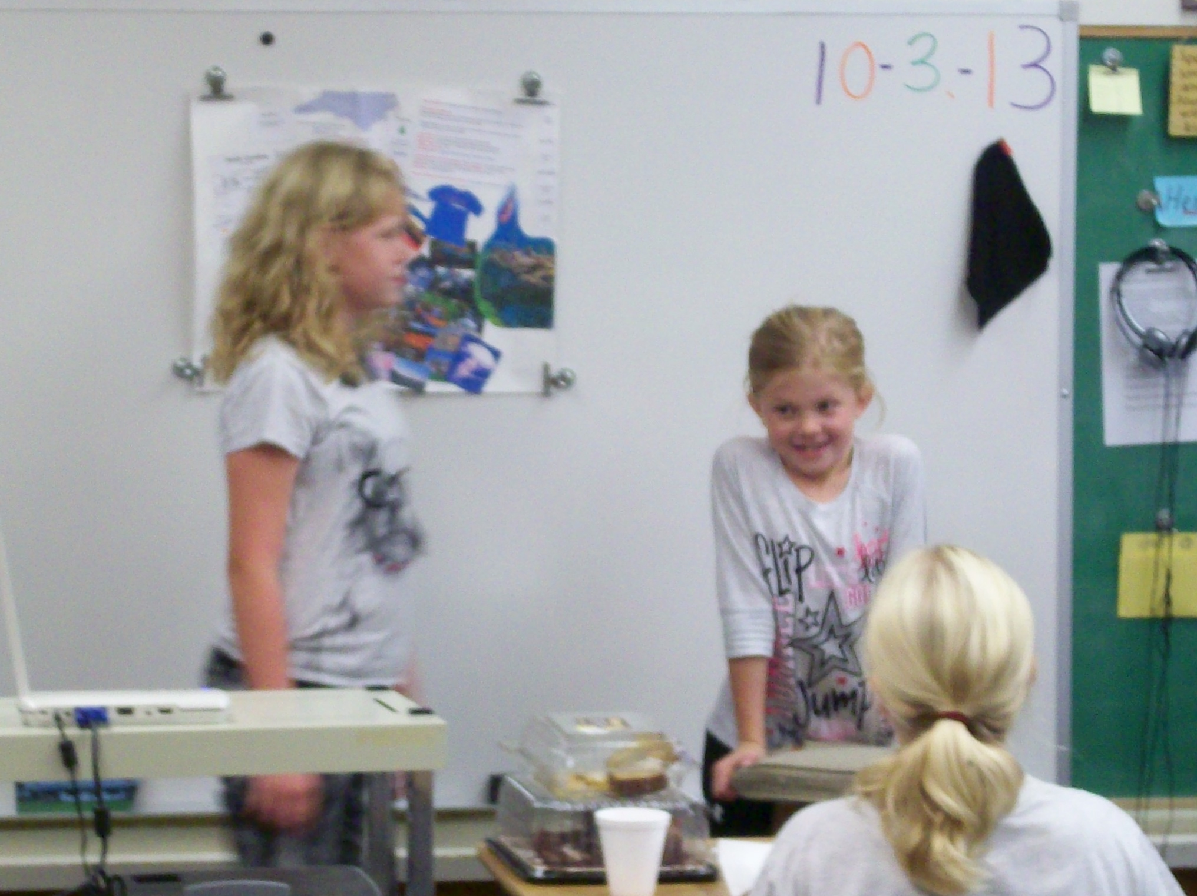
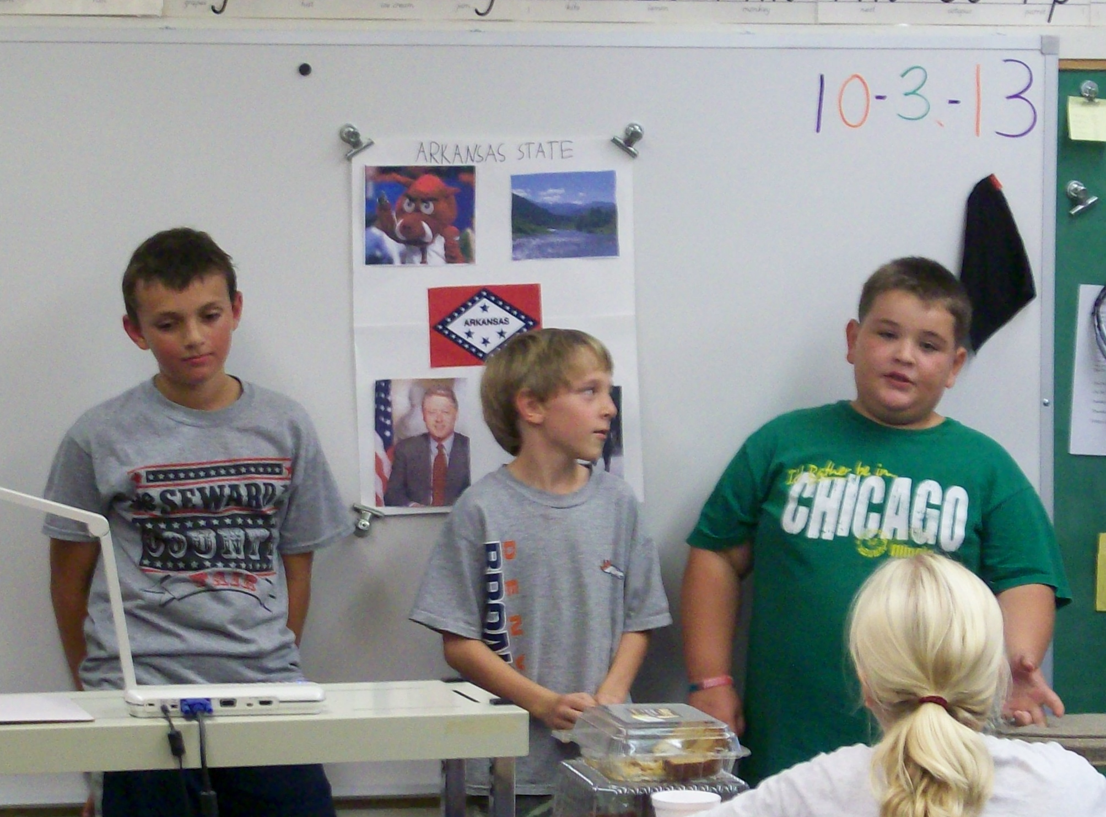

Reflection

- Analyze student learning progress from the pre-assessment to post-assessment. What conclusions can you draw from whole class as well as individual results? Use data to support your conclusions.
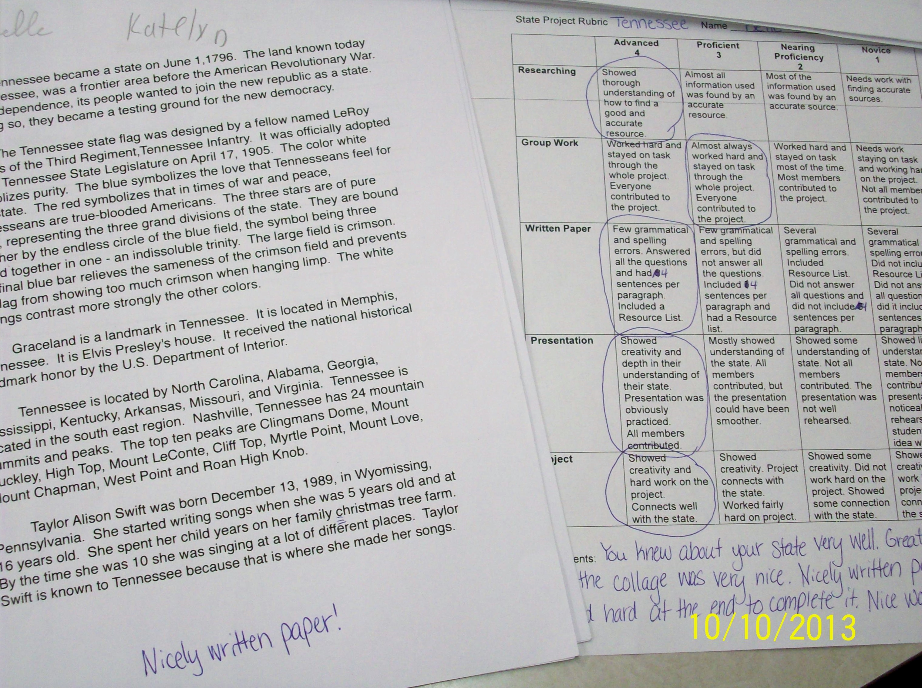
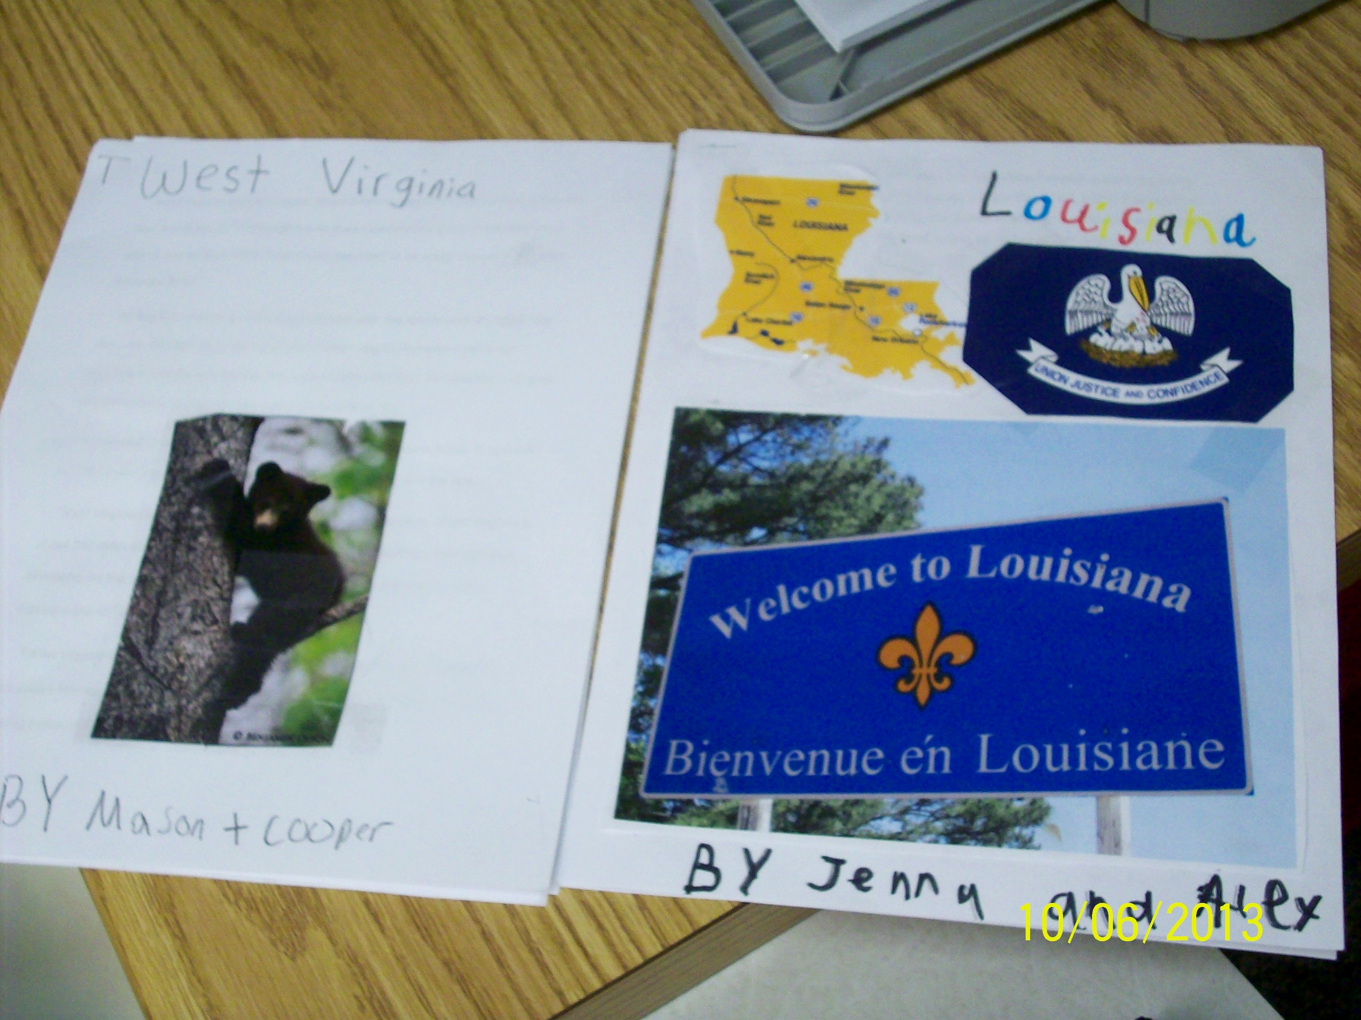
- As a class overall, the students have made a great amount of progress from the pre-assessment to the post-assessment. Looking back at the results from the pre-assessment, five students gave themselves the lowest rating when they were asked if they thought they could find accurate information on the internet. Now, the students were able to exercise what they learned in class to look up the information needed for their projects. They knew which websites were better to use for accurate information than other sites. Eight students in the pre-assessment rated themselves at the lowest rating when they were asked if they could write a bibliography. I did not actually assign a bibliography, but they all were able to write a resource list. They learned to record the websites they used when they found their information which was what I wanted them to learn. The two areas the class struggled with most were the writing of the paper and group work. It seemed fairly hard for the students to stay on task and work together to complete their projects. Some students had a harder time with this than others. The paper was a little hard for some students to complete as well. They were supposed to have someone proofread the rough draft and then they were to type the final draft on the computer. Some groups had more grammatical errors than others, but that was pretty much all that was wrong. They did a fairly good job in writing the paper with details and information they had researched. Child 1 did great in all the areas tested. He had rated himself rather low in all the areas of the pre-assessment except for the group work. The group work, though, was actually the area he did not score very well in the post-assessment. I gave him a 3 on the 4 rubric scale because he did not work well with his group at the beginning. However, he did much better as the project went on by contributing and helping with the presentation. Child 2 did a great job in the project. He showed great understanding and was able to work with his group to research and write the paper and project. I witnessed him researching for information and contributing to the project ideas. He received one of the 100% grades in the class. Child 3 rated himself fairly low about finding accurate sources and writing a bibliography. He worked hard trying to find information. Sometimes it was a little hard for him to stay focused on the task at hand, but he still did a pretty good job. He also was able to record the sites he used when finding the information. Child 4 rated herself fairly high on all the questions in the pre-assessment. She did seem to do pretty well. I think she learned more about what made a source an accurate source than what she indicated in the pre-assessment because she had to ask a few questions about whether one source was right or the other. We talked about how she would need to find another source to compare. She also had a little problem with focusing on her group work, but in the end was able to get the job done. Child 5 started out his pre-assessment rating himself pretty low with writing the paper and searching for information. However, he did a good job with working with his partner and searching for the correct information. The only area I found he needed to work on was writing the paper with fewer grammatical errors in his writing. Child 6 actually rated himself pretty high in all the areas of the pre-assessment. The only area he thought he really needed help with was the bibliography. He was able to write his resource list, though, and did a very good job in all the other areas of the project. He was also one of the students receiving a 100%. Child 7 rated herself fairly low in all the areas of the pre-assessment. She did fairly well in the post-assessment, but I did notice she did not fully understand how to search for accurate information on the internet. She relied on her partner to search for the information which became clear when her partner left during the period for a little while and the girl could not look for any information. Relying only on their partner was not something the students were supposed to do and they knew that so she was docked a little for that. She and I also had a mini-lesson on searching for information on the internet. Child 8 rated himself fairly low on many of the areas in the pre-assessment. However, by the post-assessment he was able to find accurate information on the internet and write a resource list. He was also able to work with his partner fairly well, although he received a 3 on the rubric because the students were not always focused on the project at hand. Likewise, he was able to write a paper. Although it had a few grammatical errors, it still had good information. He made great improvements since the pre-assessment. Child 9 rated herself fairly low on the pre-assessment as well. She had troubles throughout the project with staying on task, but in the end was able to get her work done with her partner. She did a great job with her presentation as well because she stayed serious even when her partner started laughing hysterically halfway through. This was a new side of the child that I was very happy to see. She made great strides in group work. She also learned how to write a paper fairly well receiving a 3 on the rubric. She was also able to research on the internet although she did have a harder time figuring out how to do that. She was a hard worker. Child 10 rated himself fairly high through all the areas in the pre-assessment. He was a harder worker, but he did lose the report and resource list he and his partner were working on. They only had a couple of days to rewrite the report after this. He then received a 3 on the rubric for group work. Overall, though, I think he did well in working and searching for information. Child 11 also rated himself fairly high in the pre-assessment. I think he may have rated himself a little too high in the pre-assessment in some areas. He did know how to use the internet, but not find accurate information. We had many discussions on what made a source accurate. He also had some problems working together with his partner since they were not always on task. He received a 3 on the rubric in group work and in writing a paper. He can write, but there were a few errors. In her pre-assessment, Child 12 gave herself a 3 when looking for information on the internet. She received a 4 in the post-assessment because she really seemed to excel in looking through the internet. She was also able to write a resource list fairly well which was the other low rating on the pre-assessment. Child 13 gave herself fairly high ratings in all the areas of the pre-assessment. She really did a good job with this project. She worked hard and asked questions when she needed help. At the beginning of the project, she had a harder time including her partner in the research, but she learned to accept help from others as well. She was the other student receiving a 100% for this assignment. In the pre-assessment, Child 14 gave herself a 1 rating for finding accurate information and writing a bibliography. She learned how to use the internet for research and how to write a resource list. With both those areas, she received a 4 on the rubric because she seemed to really understand what she was doing. The only area she received a 3 for in the post-assessment was writing the paper. There were a few grammatical errors and she and her partner could have written a little more information about their state. Child 15 stated in the pre-assessment he was a little unsure about writing a paper and writing a bibliography. He was able to write the resource list just fine and look for accurate information. His paper did have some grammatical errors, but overall, it was a good paper as well. He included accurate information and made the paper interesting to read. I thought the class did a great job and made great strides in their learning from the pre-assessment to the post-assessment. This included researching, writing the paper, and giving the presentation. This was a pretty big project, but the students completed it very nicely.
- Were the unit objectives met? To what extent were they met? How do you know they were met?
- I believe, overall, the unit objectives were met. Students, for the most part, were able to follow directions. There were a few problems in regard to misunderstanding about what to research, but the students were able to work through that and get back on track again. The sources the students recorded on their resource sheets were all sources we talked about as being reliable sources. We had discussed that .org and .edu sources were especially good and many of the students remembered that information. They found it was harder to find these types of sources, though. I think that was a great learning experience for the students to find that they must research harder than just typing something into a search engine. They had to evaluate the source and see if the source sounded as though it could be correct and if it matched other sources they had already found. I found that some of the students may have not learned as much about researching information than others. These students relied on their partner a little too much and let them type in everything into the search engine and find the information. I did not realize this was going on until the very end of the unit. All the groups completed their papers which, for the most part, were written very well. They were able to use the information they found in their research to write their papers. They were also able to present the information they researched to the class. The presentations really showed how the students had thought about their state and researched it. Most of the projects showed real depth into the state. One group brought Mardi Gras King Cake which is essentially connected cinnamon rolls. They had to research how to make the rolls and why they were so special to the state. This led them to learning more about Mardi Gras and what that was all about. All the groups worked really hard to find the information and I think they enjoyed sharing the information with each other.
- Was there a lack of progress made for the whole class or for individual students? If so, what were the factors that impeded student success?
- Some individual students made a little less progress than the rest of the class. One of the students had a hard time understanding what he was supposed to be researching. He also had troubles looking for the information on the internet search engine. Toward the end of the unit, however, I think he had a firmer grasp on how to find the information. I think he just needed practice and by the end of the project, his partner was starting to focus on the project as well. This helped the younger boy understand what he was supposed to do. Another student I thought may not have showed quite so much progress as the rest of the class had problems working together in a group. From the beginning of the unit, he was the child I was the most nervous about being in a group. However, the student did better than expected, yet he still was not able to research the correct information. He kept going to other sites on the internet. I think this was more about what he wanted to do at that moment than not understanding how to search for information on the internet, though. One other student still does not yet know how to accurately type in information to the search engine and find what she is looking for. I think she relied too much on her partner who seemed to do a good amount of the searching. I did not do as great of a job with checking in on the students in that way. I should have made sure both students were searching for information the same amount. This group had been having one partner search for information while the other wrote down the notes and wrote the paper. This was good teamwork, but the girl missed the practice of learning how to use the internet. They had been using one of the two computers in the classroom while most of the other groups had been using the iPads. This allowed for this particular girl to get off on just allowing her partner to do all the research since they only had access to one computer.
- Knowing what you know now, what modifications would you make to content and/or methodologies if you were to teach this unit again?
- I think that I would not make this as much of a research paper project. The point of the project was to have them research about their state and find good sources to back up the information. I believe that is a good objective and goal to have for the unit, but I do not think I would make the class write a paper. If I ever do this unit again, I would have the students choose two projects to do. They could do any two projects while researching about their state. They would still have to keep a resource list and find information about the state from good resources, but they would not have to write the paper. I think the paper was a little much for some groups to handle. Some groups did very well with the paper, but others struggled greatly. Writing a paper could be one of the choices for the projects, but it would not be a requirement. The students seemed to be scrambling to try to get done with both their papers and projects. This was a little too much for some students to handle, especially the younger students. Some groups had not even started working on their projects until the night before the presentation. I had made sure they knew what they were doing weeks before, but they were too busy researching and writing their papers to work on their projects. I think this may have been too much of a challenge for some of the students.

Personal Professional Growth

- What did you learn about effective instruction as a result of this experience?
- I learned a great deal about effective instruction. Group work can be a great thing, but it can also be very time consuming and hard. Students have to learn to work together and get the work done. This is not always easy for some students. I learned that I have to know what I want to say and teach at the very beginning of the lesson because it is not an easy task to get the students’ full attention while they are working in their groups. At the beginning of the period I need to make sure to give all the directions clearly to the students so they know exactly what to do and what I expect of them. I think I also may have given them too many papers because many of the students lost many papers and could not find directions for certain parts of the project. I should have made sure to name a specific folder they needed to keep all their social studies papers in so they would not lose them. I learned that as I went along and started to make sure the students did that toward the end of the unit. I also think that the internet was somewhat of a problem for some students as well. If I were to have a class with only third or fourth grade students, I think I would use technology a little more and narrow down the internet sites the students were able to look at. I could use a site called Symbaloo where the students would only have to click on one of the squares on the page to look up information about their state. This would still be researching, but it would cut back on trying to look through all the internet pages and getting into inappropriate webpages. I think the way I did this project with the fifth grade students working with the younger students was probably fine because the fifth grade students were better able to help the younger students. However, if I had a younger class I would make sure to narrow down the possible websites.
- How has this experience changed your perception of yourself as a teacher?
- I knew from the start that I had a long way to go in becoming a good and effective teacher. I am still learning and trying my hardest. I think, though, this unit has given me a little more confidence in my teaching ability. At the very beginning of the unit, before I gave my first lesson, I was so nervous and scared to get up in front of all three grades for the first time and teach. However, it was not as bad as I had thought. I faced the students and they listened to me. I knew what I wanted to say and I felt pretty comfortable there. I am not saying that I felt that way all the time, but I do feel more comfortable and happy in front of the class than I had before. I also know that I need to be clearer about the directions I want the students to follow. Somehow many students in the class seemed to miss the instructions. I need to make sure the whole class is listening and clearly state the instructions on one sheet of paper. I had given the bubble map, instructions, and checklist all in a stapled packet. I think that was too many papers for the students to handle all at once. I also do not think they understood what the checklist was exactly. I will try to change the format of that if I do this unit again. I think that was more harmful than helpful because the students kept trying to check things off the list when really the checklist was to show them what I was looking for by the end of the project. Overall, I learned that I need to be clearer and probably a little more firm with the students. I also now see that I can be a great deal more confident and comfortable in front of a class of students.

