Student Teacher: Robert Cody
Cooperating Teacher: Mrs. Christy Ruhl
School: Milford Elementary
Context of Teaching
I have the honor of teaching in Mrs. Ruhl's 6th grade general music classes. The class is in two sections that meet twice a week for 30 min. Each class has one specific student with behavior challenges. Both fall under the title "class clown,” and have already gained that reputation throughout the school. The students offer a big challenge to classroom management, as they are both prone to make comments that, when left unaddressed, will unravel the whole class. Beyond that, the students are generally energetic and talkative, but responsive.
This unit is within the confines of a semester theme. The whole semester is focused on American popular music from 1900 to now. Each unit was supposed to take up a week's worth of instruction time. That means we had 3 class periods, each one being 30 minutes long.
Mrs. Ruhl told me that as long as her objectives were met, that we could use any means to get there. Her overarching question is "Why does music change over time?" The first class period adheres to this question, providing numerous details of changes of the day and explaining the roots of blues and their social influences. Also included in this section is the objective to have students improvise. The last two thirds of this unit revolve around that objective. The composition of the blues lyrics is a form of improvisation. Then the last day, the students will be able to improvise at its core. With those things in mind, we were free to of other curricular influences. This allowed for complete teacher invention and experimentation.

Stage 1 – Identify Desired Results
Established Goals:
National Standards for Music Education
1. Singing, alone and with others, a varied repertoire of music.
2. Performing on instruments, alone and with others, a varied repertoire of music.
3. Improvising melodies, variations, and accompaniments.
4. Composing and arranging music within specified guidelines.
6. Listening to, analyzing, and describing music.
9. Understanding music in relation to history and culture.

What understandings are desired?
Students will understand that music changes for many reasons including social factors, technology, foreign influence, and innovations.
Throughout history, music has been used to express the human condition.
What essential questions will be considered?
Why does music change over time?
How has music been used to express the human condition (namely in blues)?

What key knowledge and skills will students acquire as a result of this unit?
Students will be able to define:
AAB, 12-bar blues, Bessie Smith, "Ma"Rainey

Students will be able to describe:
What social circumstances influenced blues lyrics.
What instruments were commonly used to play the blues.
The form for 12 bar blues.
AAB form in poetry.

Pre-Assessment
Name:
Bessie Smith
Who? I’ve heard of her. I’m a “Ma” expert.

12 Bar Blues
What? I’ve heard of it. I’m an expert.

“Ma” Rainey
Who? I’ve heard of her. I’m a “Ma” expert.

AAB Form Poetry
What? I’ve heard of it. I’m an expert.

*The following graph analyzes student answers to pre-assessment. You will see that the majority of the students felt clueless about all four key learns.

*This graph analyzes correct and incorrect answers
as provided by the day 1 exit card.

Narrative:

The first day was the most important day in terms of key learns. AAB, 12 Bar Blues, “Ma” Rainey, and Bessie smith were the important elements that needed to be learned as a base for the blues exploration. The PowerPoint instruction was effective based on the assessments provided. In retrospect, a final review would be a good idea to understand if the students remember past the first class period.

Stage 2 – Determine Acceptable Evidence

Students will use negative circumstances in their life to compose blues lyrics of their own (indicating understanding of blues influences, and AAB poetic form).
Students will improvise on mallet instruments to the form of 12-bar blues (indicating understanding of 12-bar blues form and understanding of improvisation).

Performance Tasks* (summary in GRASPS form):
G- The students will write their own blues lyrics using AAB poem form with rhyme scheme.
R- The students will be composers of their own music and improvisational jazz performers.
A- The student will have their lyrics performed for other students and the instructors as well as perform their improvisations for their instructors and fellow students.
S- Blues lyrics will be performed and sung by Mr. Cody and Mrs. Ruhl in the front of the classroom using a piano and guitar. The students will be improvising on mallet instruments on the solo breaks of their blues song. This will be done at the front of the class.
P- This will be recorded, so the student will have a recording of their blues song and themselves improvising. In the end, they will have blues lyrics of their devising, and a recording of their performance of that song.

S- The rubric is attached and will be available to students throughout the lesson.

Other Evidence (quizzes, tests, prompts, observations, dialogues, work samples):
Attached pre-assessment

Student work:
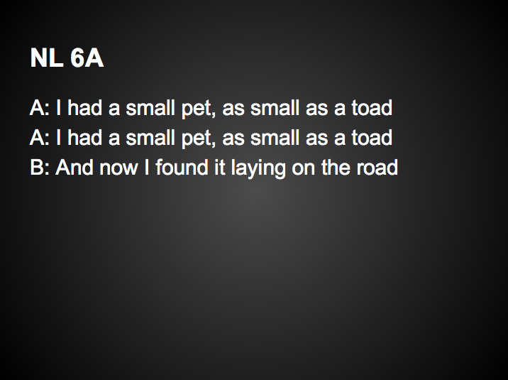

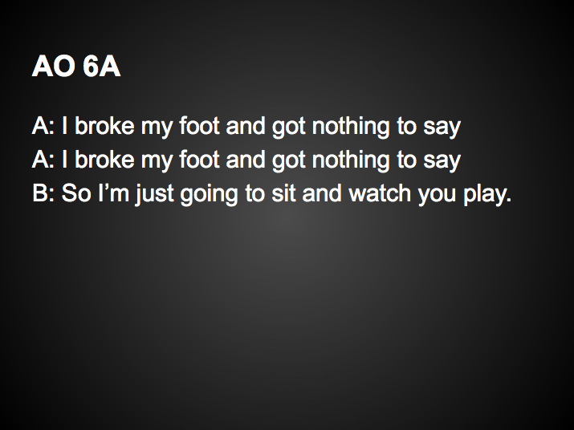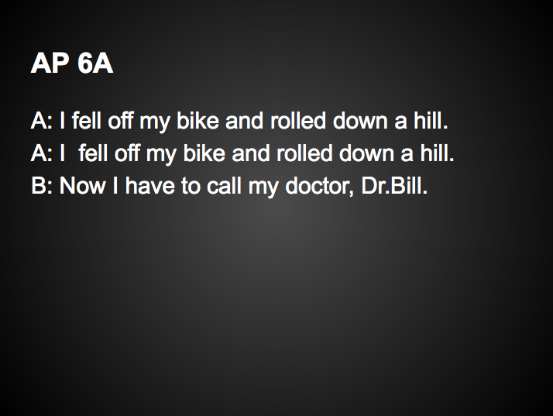

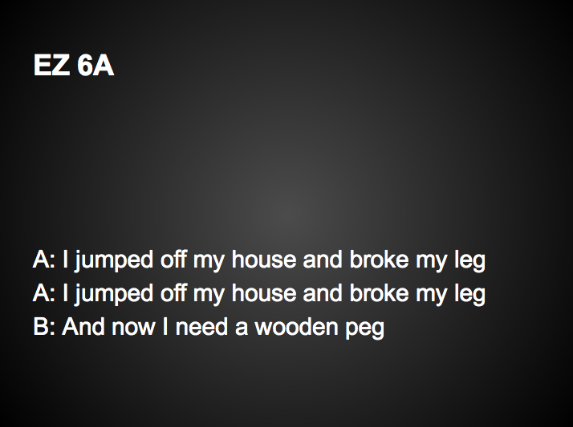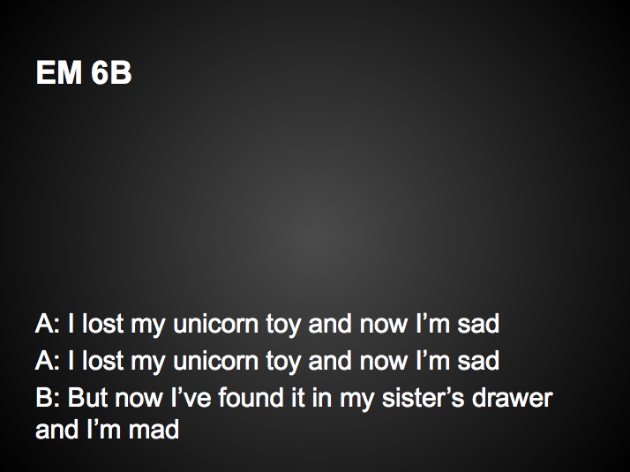

Attached day 1 exit card:
“Ma” Rainey was known as the “Mother of Blues.” T/F
Bessie Smith died in a car accident. T/F
AAB poetry makes a statement, repeats it, and then repeats it again. T/F
The blues are often performed in the same way called the 30 bar blues. T/F

Video recording of performances (unavailable in this format, available upon request, robert.cody@cune.org).

Attached rubric for blues lyrics (see post assessment).

Student Self-Assessment and Reflection:
Name:____________________________

Please write one thing you learned about the blues:

Please write a question you still have about the blues:

Please write your favorite thing about this lesson:

Post-Assessment
Blues Lyric Rubric NAME:________________________
 | Basic | Improved | Proficient | Advanced
Creativity | Common blues theme. | Fairly uncommon blues theme. | Very unique blues theme. | Mrs. Rule and Mr. Cody have rarely heard your theme.
Verses | 1 verse | 2 verses | 3 verses | 3 verses making that make some logical sense together.
AAB form | Does not accurately employ AAB form. |  |  | Accurately employs AAB form.
Rhyme | No Rhyme Scheme | Rhyme Scheme on 1 verse. | Rhyme scheme on 2 verses. | Rhyme scheme on all verses.

Student Teacher: Robert Cody Grade Level: 6th Date: 9/19
State Standard: NAfME 1, 2, 3, 4, 6, 9 Subject: General Music
Name of Lesson: Blues Period / Time: 2:35-3:05
I. Goal:  NAfME 1, 2, 3, 4, 6, 9 | Required Adaptations/Modifications:
II. Objectives:  -Students will be able to define:  "Ma" Rainey  Bessie Smith  AAB form poetry  12-bar blues  -Students will be able to describe the social situations in the blues era.  -Students will be able to name 2 roots of blues (field hollers, praise songs/spirituals). | Required Adaptations/Modifications:  --Students will have the option of performing solo or with a partner. We understand that performance anxiety may be a real concern, so we want to make students feel as comfortable as possible.
III: Faith / Values Integration:  -Class will discuss the nature of segregation that caused blues to be located majorly in the African American population. | Required Adaptations/Modifications:
IV. Integrated Technology:  See attached PPT.  Students will create a study documents in Google docs. | Required Adaptations/Modifications:  -One student requires "dictation," (teacher types while student speaks their desired notes).  -Students with visual imparements may rearrange seating or view presentation on a personal device (iPad).
V. Materials:  MacBooks  White board for demonstration | Required Adaptations/Modifications:
VI: Procedure:  FORMTEXT  A. Set / Hook:  - Students enter the room and receive a pre-assessment that is filled out while role is taken.  - Students are asked to whistle two pitches.  - Once pitches are established, teacher introduces concepts of 12 bar blues and improvisation.  -Teacher plays 12 bar blues, while students improvise on two whistle pitches.  B. Transition:  -This idea became standard during the blues era. Let's learn more about how it came about.  C. Main Lesson:  - Teacher administers direct instruction using PPT on "The Blues."  D. Transition:  - Now that we know the ideas of 12 bar blues and AAB for, I'll tell you how we're going to use them both next time.  E. Conclusion:  -Explain next time’s events, revealing that we will write our own blues lyrics.  -Have students fill out exit card (see pre-assessment). | Required Adaptations/Modifications:  -Some students require closer seating to the board. Those students who require close sitting are asked to scoot forward in the room.  - Students who have severe sight disabilities are given the option to view the PPT on an iPad.  - Students with histories of behavioral issues are seated strategically in the front, close to the teacher's instructional space.
VII. Assessment:  -Exit card (see assessment) asking students to indicate understanding of 4 pre-assessed subjects (multiple choice). | Required Adaptations/Modifications:
VIII. Assignment:  *Think about possible subjects for blues lyrics (be VERY CREATIVE). | Required Adaptations/Modifications:  *Some students may require prompts for creativity, examples and ideas of others. Have previous examples on hand.
IX. Self-Evaluation:  We found ourselves teaching to the test. In concern for making sure the students knew what was coming, we found ourselves focusing heavily on the test questions and when time was running out, other things were sacrificed for the sake of getting to the test subjects. | X. Coop’s Comments:  Bobby did a great job introducing students to the 12 Bar Blues. The students love to whistle and he did a wonderful job incorporating that into the lesson in a constructive manner. Bobby's enthusiasm for the subject matter made the kids very excited to learn.

Student Teacher: Robert Cody Grade Level: 6th Date: 9/24
State Standard: NAfME 1, 2, 3, 4, 6, 9 Subject: General Music
Name of Lesson: Blues Period / Time: 2:35-3:05
I. Goal:  NAfME 1, 2, 3, 4, 9 | Required Adaptations/Modifications:
II. Objectives:  -Students will create blues lyrics using AAB form using rhyme scheme with 100% accuracy as assessed by attached rubric. | Required Adaptations/Modifications:  -Dictation may be required for students with fine motor skill impairment.
III: Faith / Values Integration:  - Students will discuss how bad times were for people who were writing the blues. Comparatively they can consider their lives improved and be thankful for the freedom we all celebrate today. | Required Adaptations/Modifications:  None
IV. Integrated Technology:  -Google presentation for collecting and displaying student lyrics. | Required Adaptations/Modifications:
V. Materials:  - All students must have MacBook upon entry.  -Computer for 1920’s dance music | Required Adaptations/Modifications:
VI: Procedure:  FORMTEXT  A. Set / Hook:  - Review AAB form on the board.  - Explain students will have the rest of class to write their blues lyrics.  B. Transition:  - Say: Begin working on your lyrics.  C. Main Lesson:  -Students write their lyrics into Google docs presentation and share it with Mr. Cody  - When all have completed, have students type notes into Google docs.  - As students finish, they relocate to hallway.  - Explain 1920’s dances and have students engage in dances as they appear.  D. Transition:  - Once all students have finished notes and are dancing. We tell them our assessment of their work that day. Then have them go inside to their rows.  E. Conclusion:  - Release students as they show us they are ready. | Required Adaptations/Modifications:  *Students may require dictation.  *Students may need examples to be creative in their lyric writing.
VII. Assessment:  - Student lyrics are available for teacher reviewing via Google docs. Teachers will assess via rubric.  - Student participation in dances will be assessed by teacher observation. | Required Adaptations/Modifications:
VIII. Assignment:  No assignment. | Required Adaptations/Modifications:
IX. Self-Evaluation:  The Google docs are a great idea, but require careful planning and assuredness of information. A couple students had to have the presentation re-emailed to them. Most of the students did not receive and email that shared the presentation for lyrics with them. They had to find an alternate way to discover it was shared with them. That way was more reliable. In the future it would be better to have them do that first. | X. Coop’s Comments:  GoogleDocs-Presentation was used to record the blues lyrics. Bobby impressed me with how he was able to use technology to gather student work in an efficient manner.

Student Teacher: Robert Cody Grade Level: 6th Date: 9/19
State Standard: NAfME 1, 2, 3, 4, 6, 9 Subject: General Music
Name of Lesson: Blues Period / Time: 2:35-3:05
I. Goal:  NAfME 1, 2, 3, 4, 6, 9 | Required Adaptations/Modifications:
II. Objectives:  -Students will perform an improvisation over a 12 bar blues.  -Students will respectfully listen to other students’ performances. | Required Adaptations/Modifications:  -Students will have the option of performing solo or with a partner. We understand that performance anxiety may be a real concern, so we want to make students feel as comfortable as possible.
III: Faith / Values Integration:  - We will discuss the importance of creativity and how it inspired many of the inventions during the time of blues and how they can still inspire today.  - Relate improvisation directly to creativity. | Required Adaptations/Modifications:
IV. Integrated Technology:  Google presentations provide a way for students to quickly get their compositions on one document to share. | Required Adaptations/Modifications:  *Students may require dictation.
V. Materials:  Projector  Screen down  Barred instruments (prepared with Bb)  Mallets*  Lyrics PPT (queued)  Mr. Cody’s guitar and amplifier | Required Adaptations/Modifications:  *Student with limited mobility in left hand requires adaptive mallet device.
VI: Procedure:  FORMTEXT  A. Set / Hook:  Mrs. Ruhl and Mr. Cody sing the example blues and Mrs. Ruhl improvs over 12 bars of blues.  B. Transition:  -It's your turn! Students are prompted to be very respectful of other students while they perform and their lyrics are performed. Students are also instructed to follow the model set by Mrs. Ruhl and Mr. Cody  C. Main Lesson:  - Students observe and perform their lyrics in turn and in time.  D. Transition:  - Mr. Cody provides feedback on the general impression of the lyrics.  - Hand out evaluation (attached p.).  E. Conclusion:  - Students fill our self-evaluation while we watch videos of blues performances. | Required Adaptations/Modifications:  -Some students require closer seating to the board. Those students who require close sitting are asked to scoot forward in the room.  - Students who have severe sight disabilities are given the option to view the Prezi on an iPad.  - Students with histories of behavioral issues are seated strategically in the front, close to the teacher's instructional space.
VII. Assessment:  - Rubric attached in post assessment. | Required Adaptations/Modifications:
VIII. Assignment: | Required Adaptations/Modifications:
IX. Self-Evaluation: This was hands down the best part of the whole project. The students were very responsive to the live interactive classroom. It was something different than they have ever done before. For the most part, behavior was not an issue. In all, I think that the students did not understand the scope of the project, and while all of their lyrics were functional, I think some of them would redo if they had the chance knowing how much fun it could be. | X. Coop’s Comments:  Bobby was able to bring the Blues to life for the students. He was a wonderful performer and encourager. He created a positive experience for students who were allowed to improvise on the malleted instruments.

Reflection:
The true beauty of this lesson was that, by and large, the kids were completely clueless to the subject matter. We were starting with a blank slate. The pre-assessment results reflect this with most of the students marking themselves as clueless in most categories. The post assessment (exit card) for day 1 showed much improved results. The students could recognize the four subjects by answering a T/F question about it. For this unit, however, the most important assessed activity was the blues performance and writing of the lyrics. The following chart presents the class’ score as ascribed by the rubrics.

The majority of the students created proficient work scoring them a four. There were three students whose lyrics were creative, and they merited a five for taking the assignment to heart, and putting a great deal of creativity into it. In regards to the students’ improvisations, the students have had very little experience with this in the past. For some of them, this was their absolute first experience. Therefore, we did not critique the improvisations for a grade, simply provide insight, observations, and suggested improvements at the time of the performance.

The students who did not get correct answers on the exit slip correlated to the students who put the least amount of work into their blues lyrics. I believe in this case, student success was impeded by their attitude toward the classroom. The students are at an age where some of them believe music to be unnecessary, or childish, or any combination of things that do not suit them. In this lesson, I discovered that some students have a lack of motivation in this class. After this lesson, I have set my sets and creating better relationships with these students, including them more and more in each class and finding ways to engage them, because I really think they missed out on something that could have been very fun for them by having a poor attitude. Having some way of assessing student attitudes before starting the unit would have been helpful, because I could have started this process prior and during the unit itself.

Knowing what I know now, I would have made more time for this unit. The blues are such an influential time in history, especially in music history. I think the students felt rushed to get through the material (because I did). This prevented some genuine interaction with the themes present during the blues. I also would have done a better job emphasizing the scope of the composition assignment. Students were unclear as to how their compositions were going to be performed and the publicity of their performances. Had they kept these things in mind during the composition, I believe the final products may have been at a higher level.

**Personal Professional Growth

During this experience, I learned that a spectrum of instruction exists. There is a basic way to deliver material. Strictly speaking it to the students and praying they will remember it is on one end of the spectrum. The other end is strictly experience with zero talking. If students could just have an experience without any verbal guidance, they would learn something, but not necessarily what we as educators want them to. I believe the best teachers are those who find a balance between how much they use their mouth and ideas and how their interaction guides student experience. The best lesson plans, therefore, are those that include experience (as that is how we learn) that is guided by the instructions, procedures, objectives, and heart of a teacher. I did my best to apply these concepts in the lessons above. I think the result was that students walked away with more than they would have if they had just had the information spoken to them, and they walked away with the things we wanted them to, as well as other things they learned in the experience.
Throughout the planning of these lessons, I was remembering the kind of teacher I want to be. There are a number of teachers from my past who were on the “speaking” side of the spectrum I described above. These classes were never interesting to me (unless they were music classes, and I was taking those lectures into the field and experiencing the content on my own time). Yet, I have had teachers who were loose and disorganized under the guise of “experience.” This was often laziness and students rarely learned what the teachers wanted them to. Instead they learned how to cheat the system. In all this I decided that I want to be a teacher that created beneficial experiences for students to have, and that I want to be the teacher who will do anything he can to help them be successful in that experience. If they are not successful, I want to provide them with tools to do better and learn from their mistakes. It has solidified in my heart my love for students, learning, and music.

Teacher Work Sample – Electronic Submission Document

