

Administrators, Dual Credit Teachers and Coordinators,

Thank you for being a partner with us in offering Concordia University Dual Credit to your students – your partnership is so valuable to us, and so are your students.

The opportunity to take Dual Credit courses is not available to all high school students, and certainly not available to most students in the form of face-to-face instruction in their own high school classrooms. Thank you for your part in providing that opportunity. In our ongoing effort to support academic successes, I want to acknowledge your students’ achievement by inducting them into the ***Concordia Academy***.

All of your high school students who successfully complete nine credit hours of Concordia Dual Credit course work will be automatically inducted into the ***Concordia Academy***. Each of them will receive an award certificate, t-shirt, and letter, welcoming them as members of our Concordia community. Additionally, the enrollment fee will be waived for ***Concordia Academy*** members who choose to attend CUNE full-time.

I want for induction into the ***Concordia Academy*** to be fun and meaningful, and to that end, if you have a Spring Awards event of some kind, where students receive acknowledgements of successes, I welcome your help in presenting these awards. Awards will be delivered to your school for distribution as is best for your schedule and students.

My Dual Credit office has already identified each student in your school who has achieved this milestone. They have each received an email asking that they provide a t-shirt size so we can reward them properly.

Again, thank you for being a partner with us in offering Concordia University Dual Credit to your students. Your partnership is so valuable to us, and so are your students.

With gratitude and excitement!

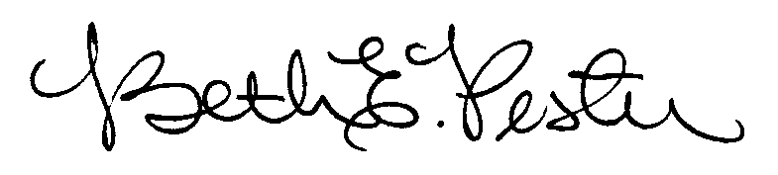

Dr. Beth Pester

Director of Dual Credit

Concordia University, Nebraska