

<Name>,

Congratulations from Concordia University Nebraska on your fantastic academic achievement of successfully earning Concordia University Dual Credit! I pray your year is going well and you’re looking forward to the summer!

The opportunity to take Dual Credit courses is not available to all high school students, and certainly not available to most students in the form of face-to-face instruction in their own high school classrooms. Thank you for taking advantage of the opportunity. Because you have earned at least nine credit hours of Concordia University Dual Credit, you are now officially a member of the ***Concordia Academy*** here at Concordia University, and that’s something special.

Being a member of the ***Concordia Academy*** comes with some great benefits, and if you haven’t made a college decision, you might want to know about them:

* **Your enrollment fee at Concordia University has been waived** – no need to pay $200! And if you’ve already enrolled and paid, we’ll refund your payment. Please contact the Admissions Office at 402-643-7233 to request that the enrollment fee be waived or refunded.
* There’s no need to worry about whether your credit will transfer here to Concordia University – **your credits already belong here, just like you do**!
* Because your credits belong here, you have already met some graduation requirements, which means you have **some great academic options**. You have room in your schedule to add a minor, double major, perhaps graduate early, or add a few courses that just sound really fun to take!
* Continuing your education at Concordia University with the CU-DC credits you’ve already earned means a **tuition savings of at least $8000**, and that’s just for earning nine credits – it’s a bigger savings if you’ve earned more!
* **You are already a part of our Concordia community, being a member of the *Concordia Academy*, why not come to campus full-time and join the rest of us on your next adventure!**

Thank you for taking Concordia University Dual Credit. I hope your last days of this high school year are full of great memories and celebrating your high school successes. **And I hope to see you full-time on campus in the future.**

Welcome to the ***Concordia Academy!***

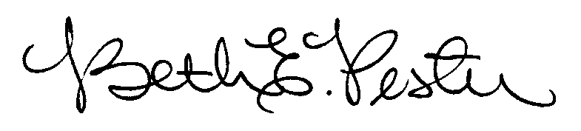

Dr. Beth Pester

Director of Dual Credit

Concordia University, Nebraska