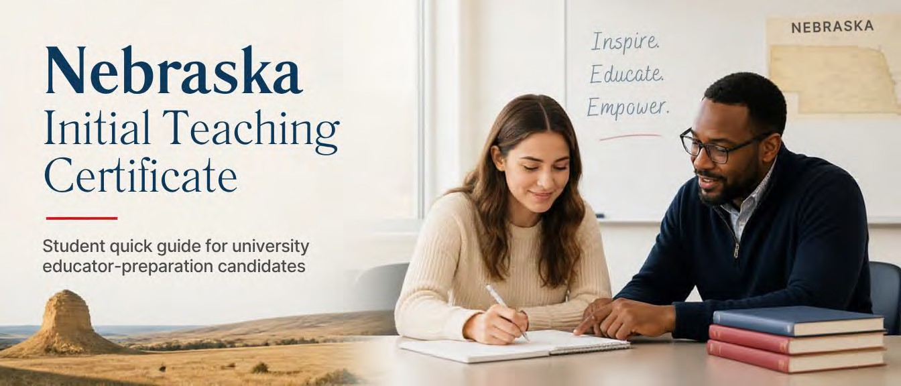

Office of Educator Certification | Nebraska Department of Education
This guide provides an overview of the key steps, timelines, and requirements for obtaining an Initial Teaching Certificate in Nebraska from the Nebraska Department of Education. It is intended to help educator certification candidates understand the certification process and prepare for a successful application.
What you will accomplish
By the end of this guide, you will understand how to prepare for and submit your Nebraska Initial Teaching Certificate application through Teach Nebraska.
Audience: University students and educator-preparation candidates.

Why Your Nebraska Teaching Certificate Matters
A valid Nebraska teaching certificate is required to teach in Nebraska schools. It also:
- Allows you to teach in public and nonpublic schools.
- Allows unlimited substitute teaching.
- Makes it easier to transfer certification to another state.
- Provides opportunities to add endorsements and pursue administrative roles.

Initial Certification Timeline
- Apply Early: Submit your application through Teach Nebraska.
- Complete Your Program: Finish student teaching and all degree requirements.
- Institution Verification: Your institution submits Institutional Verification (IV), HRT Verification, and SPED Verification.
- Application Review: The Office of Educator Certification reviews all required materials.
- Certificate Issued: Your Nebraska Initial Teaching Certificate is issued if all requirements are completed.
Important
Applicants are encouraged to submit their certification application before graduation. Applying early helps ensure your application is ready for review once your institution submits program verification.

Getting Started
Congratulations on nearing completion of your educator preparation program! This guide outlines the steps you need to take to apply for your Nebraska Initial Teaching Certificate.

Before You Apply
Create or log in to your Teach Nebraska account.

Application Steps
Select the following options:

Application field | Selection
Certificate or Permit Type | Teaching
Have you held a Nebraska Teaching Certificate? | No
Have you held an educator license in another state? | No
Applicant Type | First-Time Applicant
Certificate Type | Initial Teaching Certificate
Certificate Category | All School Certificate or Permit
Note
These selections apply to most applicants completing a Nebraska educator preparation program and applying for their first Nebraska teaching certificate. Applicants who have previously held a teaching certificate (excluding substitute) or an educator license may need to make different selections.

Complete all required personal information.
Select your institution from the Academic Record tab.
- Degree: Baccalaureate
- Date Conferred: Enter your anticipated graduation date. Answer all Personal & Professional Fitness questions.
- Provide documentation if requested.
Do not enter anything on the Testing page. Select Save and Next.
Do not enter anything on the Experience page. Select Save and Next. Complete the fingerprinting section.
- Fingerprinting is not required if you currently or have ever held a Nebraska teaching certificate, including a Local Substitute Certificate.
- If you have lived in Nebraska for the last five consecutive years, submit a Record of Residence
covering only the past five years.
- If you have lived outside Nebraska at any point during the last five years, additional fingerprinting requirements may apply. Follow the instructions provided in the application.
Pay the application fee. Submit your application.

What Happens After I Apply?
You may receive a deficiency notice indicating that the office is waiting for:
- Institutional Verification (IV)
- Human Relations Training (HRT) Verification
- Special Education (SPED) Verification
- Fingerprint clearance, if applicable
Good News!
If the deficiency notice only references IV, HRT, or SPED verification, no action is required on your part. Your educator preparation program will submit the required verification once you
have completed all program requirements.

Frequently Asked Questions
Do I need to wait until graduation to apply?
No. Applicants are encouraged to apply as soon as possible.

Do I need to have official transcripts sent?
No. If you are completing an educator preparation program in Nebraska, you do not need to send official transcripts.

Who submits my institutional verification?
Your educator preparation program submits this information directly to the office.

How will I know when my certificate has been issued?
You will receive notification through the certification system.

Need Assistance?
Office of Educator Certification
Nebraska Department of Education
📧 nde.tcertweb@nebraska.gov
🌐 Educator Certification – Nebraska Department of Education

